DUTIES DURING FIRING

Subcourse FA 3143

EDITION B

United States Army Field Artillery School
Fort Sill, Oklahoma 73503

Edition Date: October 2004

Credit hours: 6

SUBCOURSE OVERVIEW

This subcourse is designed to teach you duties during firing, safety during firing, and misfire procedures. It is one of several subcourses designed to prepare you for the resident portion of the Reserved Component Officer Advanced Course. As such, some prerequisite knowledge is required. The following should be completed prior to taking this subcourse:

*FA 8000 - Field Artillery Battery RSOP and Marches.
*FA 3310 - Sweep and Zone Fires.
*FA 3312 - Use and Operation of the Gunner's Quadrant.
*FA 3420 - Primary and Alternate Methods of Lay.

Prerequisites listed are based upon skill progression within the correspondence course curricula. This subcourse reflects the doctrine which was current at the time it was prepared. In your own work situation, always refer to the latest official publications.

Unless otherwise stated, the masculine gender of singular pronouns is used to refer to both men and women.

Terminal Learning Objective

ACTION: You will identify correct firing procedures, safety during firing, and misfire procedures.

CONDITION: Given the information contained in this subcourse.

STANDARD: Correctly answer 70% of the questions on a multiple-choice test covering firing procedures safety during firing, and misfire procedures.

TABLE OF CONTENTS

Subcourse Overview . . . . . . . . . . . . . . . . . . . . . . . . . . . . . . . . . . . . . . . . . . . . . . i

Lesson 1: Firing Procedures Overview

Introduction . . . . . . . . . . . . . . . . . . . . . . . . . . . . . . . . . . . . . . . . . . . . . . . 1-1
Duties of Key Personnel in a Platoon-Based Battery . . . . . . . . . . . . . . . . 1-3
Duties of Key Personnel in a Battery-Based Battery . . . . . . . . . . . . . . . . 1-5
Targets and Fire Missions . . . . . . . . . . . . . . . . . . . . . . . . . . . . . . . . . . . . 1-7
Components of the FA System . . . . . . . . . . . . . . . . . . . . . . . . . . . . . . . . 1-9
Battery FDC--Mission Processing . . . . . . . . . . . . . . . . . . . . . . . . . . . . . 1-13
Executing the Planned Fire Mission . . . . . . . . . . . . . . . . . . . . . . . . . . . . 1-17
Direct Fire . . . . . . . . . . . . . . . . . . . . . . . . . . . . . . . . . . . . . . . . . . . . . . . . 1-30
Summary . . . . . . . . . . . . . . . . . . . . . . . . . . . . . . . . . . . . . . . . . . . . . . . . . 1-36
Practice Exercise . . . . . . . . . . . . . . . . . . . . . . . . . . . . . . . . . . . . . . . . . . . 1-37
Answer Key and Feedback . . . . . . . . . . . . . . . . . . . . . . . . . . . . . . . . . . . . 1-40

Lesson 2: Safety during Firing

Introduction . . . . . . . . . . . . . . . . . . . . . . . . . . . . . . . . . . . . . . . . . . . . . . . . 2-1
Responsibilities . . . . . . . . . . . . . . . . . . . . . . . . . . . . . . . . . . . . . . . . . . . . . 2-1
Duties of Safety Personnel . . . . . . . . . . . . . . . . . . . . . . . . . . . . . . . . . . . . 2-2
Safety . . . . . . . . . . . . . . . . . . . . . . . . . . . . . . . . . . . . . . . . . . . . . . . . . . . . . 2-4
Weapons Safety Features . . . . . . . . . . . . . . . .. . . . . . . . . . . . . . . . . . . . . . 2-7
Maintaining Weapon Safety . . . . . . . . . . . . . . . . . . . . . . . . . . . . . . . . . . . 2-10
Safety Precautions for Ammunition . . . . . . . . . . . . . . . . . . . . . . . . . . . . . 2-11
Accidents. . . . . . . . . . . . . . . . . . . . . . . . . . . . . . . . . . . . . . . . . . . . . . . . . . . 2-12
Summary . . . . . . . . . . . . . . . . . . . . . . . . . . . . . . . . . . . . . . . . . . . . . . . . . . . 2-15
Practice Exercise . . . . . . . . . . . . . . . . . . . . . . . . . . . . . . . . . . . . . . . . . . . . . 2-16
Answer Key and Feedback . . . . . . . . . . . . . . . . . . . . . . . . . . . . . . . . . . . . . 2-18

Lesson 3: Misfire Procedures

General Definitions . . . . . . . . . . . . . . . . . . . . . . . . . . . . . . . . . . . . . . . . . . 3-1
Semi fixed Ammunition . . . . . . . . . . . . . . . . . . . . . . . . . . . . . . . . . . . . . . 3-3
Separate-Loading Ammunition . . . . . . . . . . . . . . . . . . . . . . . . . . . . . . . . . 3-5
Summary . . . . . . . . . . . . . . . . . . . . . . . . . . . . . . . . . . . . . . . . . . . . . . . . . . 3-14
Practice Exercise . . . . . . . . . . . . . . . . . . . . . . . . . . . . . . . . . . . . . . . . . . . . 3-15
Answer Key and Feedback . . . . . . . . . . . . . . . . . . . . . . . . . . . . . . . . . . . . 3-16

Appendix A

Section I: M102 Cannon Crew Duties . . . . . . . . . . . . . . . . . . . . . . . . . . . A-2
Section II: M119 Cannon Crew Duties . . . . . . . . . . . . . . . . . . . . . . . . . . A-7
Section III: M198 Cannon Crew Duties . . . . . . . . . . . . . . . . . . . . . . . . . . A-25
Section IV: M109 Series Cannon Crew Duties . . . . . . . . . . . . . . . . . . . . A-31
ADMINISTRATION INSTRUCTIONS

Subcourse Content. This subcourse contains three lessons, each related to one or more field artillery Duties during firing tasks. An introduction presents an overall view of the subject. Each lesson then explains how to perform each task.

Supervisory assistance -There are no supervisory requirements for completion of this subcourse.

References-TC 6-40, FM 6-50, and other materials approved by the US Army Field Artillery School.

Lesson 1

FIRING PROCEDURES OVERVIEW

In this lesson, you will learn conduct of fires on planned targets, basic fire mission processing, execution of sweep and zone fire missions, orders for direct fire, duties of key personnel, and the proper fire commands in correct sequence for each fire mission.

Enabling Learning Objective

ACTION: Identify the principles and concepts used to conduct fires on planned targets, execute sweep and zone fire missions, issue orders for direct fire, and announce the proper fire commands in correct sequence for each fire mission.

CONDITION: Given the information contained in this subcourse.

STANDARD: Correctly answer all of the questions on the practical exercise at the end of this lesson.
Answers must be in accordance with the content of the lesson.

REFERENCE: The material contained in this lesson was derived from TC 6-40, FM 6-50, and other materials approved by the US Army Field Artillery School.

INTRODUCTION

The mission of the field artillery battery is to deliver accurate and timely fires in support of maneuver forces engaged in tactical operations. The battery commander is responsible for accomplishing this mission and is assisted by several key personnel. These personnel have specific responsibilities within either a platoon-based or battery-based organization. A field artillery battery organized into two firing platoons is platoon-based. It consists of a headquarters and two firing platoons (Figure 1-1). The battery-based unit has a headquarters and a firing battery (Figure 1-2). The production and announcement of routine and special firing data on targets of opportunity, planned targets, and sweep and zone fires require care and proper application of fire direction procedures. This is critical because section chiefs are responsible for the actual conduct of fire. This is also true of direct fire procedures. Battery commanders and his key leadership are responsible for every phase of firing battery operations. They must master the technical characteristics of the weapon and the fire control instruments associated with it. Finally, as leaders, must be familiar with correct procedures (to include proper reporting procedures) and immediate actions in case of misfire, accidents, and injuries.

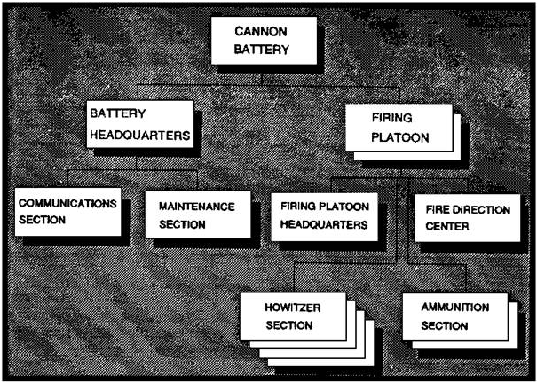

Figure 1-1. Platoon-based FA cannon battery.

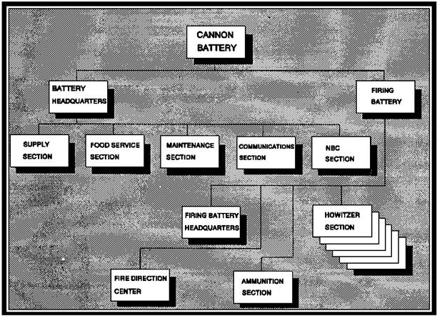

Figure 1-2. Battery-based FA cannon battery.

1. Duties of Key Personnel in a Platoon-Based Battery

a. The battery commander is responsible for all aspects of the operations of his battery. He locates where he can best command the battery, considering the factors of METT-TC (mission, enemy, troops, terrain, time available and civilian consideration) and the level of unit training. His responsibilities include the following:

(1) Supervise and standardize the operations of the platoons to the maximum extent possible.
(2) Reconnoiter and select platoon position areas after receiving direction from the controlling headquarters.
(3) Determine the azimuth of fire if it is not given by higher headquarters.
(4) Plan and direct unit marches and movements in accordance with tactical plans established by higher headquarters.
(5) Plan survey control and, when necessary, conduct hasty survey.
(6) Ensure an effective defense posture is maintained in the platoon areas.
(7) Maintain communications and electronics security.
(8) Establish security for, and supervise preparation and delivery of, nuclear weapons.
(9) Plan for ammunition resupply.
(10) Plan for logistic resupply of food service, supply, and maintenance items.
(11) Keep the battalion commander and battery personnel informed.

b. The first sergeant (1SG) is the principal enlisted advisor to the battery commander. His responsibilities may include the following:

(1) Supervise the platoon sergeants, gunnery sergeants, and section chiefs; and, whenever possible, checks the gun line.
(2) Assist and advise during reconnaissance and selection of platoon position areas.
(3) Develop and execute the overall battery defense plan.
(4) Coordinate administrative and logistical support (less ammunition), to include water and food service, laundry, showers, maintenance, and evacuation of personnel and equipment.
(5) Supervise the health care and sanitation of all battery personnel.
(6) Plan, coordinate, and execute the evacuation of casualties to the battalion aid station.

c. The platoon leader (plt ldr) is responsible for all aspects of the operations of his platoon. He locates where he can best lead the platoon, considering the factors of METT-TC and the level of unit training. He relies heavily on the platoon sergeant to supervise the firing element and the gunnery
sergeant to supervise the detailed platoon RSOP. His responsibilities may include the following:

(1) Establish and maintain the firing capability of the platoon.
(2) Supervise the displacement and movement of the platoon.
(3) Supervise the POC, and be prepared to perform the duties of the FDO to facilitate 24-hour operations.
(4) Supervise the use of the M90 chronograph and the overall muzzle velocity (MV) management program.
(5) Supervise the overall maintenance of platoon equipment.
(6) Ensure continuous security of the platoon (with emphasis during displacement and occupation of position).
(7) Compute minimum (min) quadrant elevation (QE) for each howitzer.
(8) Ensure the weapon location data are submitted and updated (on DA Form 5698-R [Weapon Location Data]) and DA Form 5969-R (Section Chief's Report) is submitted to the POC.

NOTE. Reproducible copies of DA Forms 5698-R and 5969-R are at the back of this book.

(9) Supervise and conduct hasty survey operations for the platoon.
(10) Be responsible for the ammunition management for the platoon.
(11) Be responsible for the platoon safety operations.

d. The fire direction officer (FDO) is responsible for the training and supervision of POC personnel. The FDO must also be familiar with the duties of the platoon leader, as he will at times perform those duties as well. His responsibilities may include the following:

(1) Decision to attack a target, and issue a fire order.
(2) Ensure accurate and timely determination of firing data.
(3) Ensure maintenance checks are performed on the section vehicle, radios, computer, and generators in strict compliance with technical manuals.
(4) Ensure the tactical situation map is current.
(5) Ensure accurate FDC records of missions are maintained.
(6) Ensure data for prearranged fires are disseminated and understood.
(7) Ensure data from the other platoon is recorded and available.
(8) Assume control of the fires of the other platoon when necessary.
(9) Perform independent safety computations, and verify the data with the platoon leader.

e. The platoon sergeant (plt sgt) is the primary enlisted assistant to the platoon leader and must be prepared to assume all of the platoon leader's duties. His responsibilities may include the following:

(1) Supervise the firing platoon, and maintain firing capability.
(2) Supervise occupation of the position.
(3) Supervise the overall maintenance of the howitzer sections.
(4) Develop and execute the platoon defense plan.
(5) Provide the 1SG with the platoon defense plan for integration into the overall battery defense scheme.
(6) Ensure each chief of section knows the route to both alternate and supplementary positions.
(7) Verify the completion of DA Form 2408-4 (Weapon Record Data).
(8) Ensure ammunition is properly handled and protected.
(9) Ensure safety aids are used and safety procedures followed.

f. The gunnery sergeant (GSG) supervises and executes platoon advance party operations. He must be prepared to assume the duties of the platoon sergeant. His responsibilities may include the following:

(1) Lay the platoon.
(2) Perform hasty survey as required.
(3) Initiate the development of the platoon defense plan.
(4) Assist the platoon sergeant in the performance of his duties.
(5) Ensure there is an initial fire direction capability with the advance party.

g. The howitzer Chief of Section (COS) is responsible for the training and proficiency of his section, the operational readiness of his equipment, and the safe firing of the howitzer. Appendix C, FM 6-50, presents sample tests to help in training the gunners. The section chief's responsibilities may include the following:

(1) Ensure the weapon is properly emplaced, laid, and prepared for action. The memory aid TLABSPAP is used as a guide for the accomplishment of the following tasks:

• T: Trails, spades, and/or firing platform properly emplaced. (M102A1, M119A1/A2, M198 trails are spread; spades and/or firing platform is attached.)
• L: Lay weapon. (M102A1, M119A1/A2 and M198 must be on the firing platform to complete this task.)
• A: Aiming points emplaced.
• B: Boresight Verified or performed.
• S: Second circle.
• P: Pre fire check on the weapon system performed.
• A: Ammunition prepared.
• P: Position improvement (additional aiming points, camouflage, defensive hardening
of position, and verification of lay).

NOTE. Unit SOP will dictate when to dig in spades on towed weapons.

(2) Ensure digital and voice communications with FDC are establish and maintained.
(3) Ensure ammunition is properly segregated, stored, handled, and prepared.
(4) Ensure only safe data is fired by verifying firing data, correct sight picture, and centered bubbles.
(5) Ensure DA Form 4513 (Record of Missions Fired) is properly and legibly maintained and kept current.
(6) Maintain DA Form 2408-4, and compute and record Equivalent Full Charge (EFC) data.
(7) Ensure DA Form 5969-R is completed for each position occupied.
(8) Ensure data on DA Form 5212-R (Gunner's Reference Card) are correct and current.

NOTE. A reproducible copy of DA Form 5212-R is at the back of this book.

(9) Ensure range cards are properly prepared for the howitzer and crew-served weapons, and know the portion of the platoon defense plan assigned the section.
(10) Ensure preventive maintenance checks and services (PMCS) are performed in accordance with the appropriate technical manual.
(11) Ensure cross training of crewmembers.

2. Duties of Key Personnel in a Battery-Based Battery

a. The battery commander is responsible for all aspects of the operations of his battery. He must plan and train for continuous operations in an intense combat environment. He locates where he can best command the battery, considering the factors of METT-TC and the level of unit training. His responsibilities may include the following:

(1) Supervise and standardize the operations of the battery to the maximum extent possible.
(2) Reconnoiter and select battery positions.
(3) Supervise the FDC when necessary.
(4) Plan specific actions to enhance survivability.
(5) Plan for the conduct of hasty survey; and, when necessary, perform the survey.
(6) Plan unit marches and movements.
(7) Plan the basic load mix and resupply actions.
(8) Supervise the security, preparation, and delivery of special weapons.
(9) Plan logistics for battery supply, mess, and maintenance.
(10) Establish and maintain communications and electronics security.
(11) Keep the battalion commander and battery personnel informed.

b. The first sergeant (1SG) is the principal enlisted advisor to the battery commander. His responsibilities include the following:

(1) Supervise the chief of firing battery and gunnery sergeant; and, whenever possible, check the gun line.
(2) Assist and advise the BC during reconnaissance and selection of the battery position.
(3) Develop and execute the battery defense plan.
(4) Coordinate administrative and logistical support (less ammunition), to include water and food service, laundry, showers, maintenance, and evacuation of personnel and equipment.
(5) Supervise the health care and sanitation of battery personnel.
(6) Plan, coordinate, and execute the evacuation of casualties to the battalion aid station.

c. The executive officer (XO) normally commands the firing battery portion of the battery. During extended field operations, he spends part of his time supervising technical operations of the FDC. During this time, the XO relies heavily on the chief of firing battery to supervise the battery. He also relies on the GSG to lead the advance party. The XO's responsibilities may include the following:

(1) Establish and maintain firing capabilities.
(2) Supervise battery displacement and movements.
(3) Supervise the batteries MV management program.
(4) Supervise maintenance of the battery equipment.
(5) Ensure continuous security of the battery (with emphasis during displacement and occupation of position).
(6) Compute minimum QE for each howitzer.
(7) Ensure the weapon location data report is submitted and updated and the section chief's reports are submitted to the FDC.
(8) Supervise and conduct hasty survey operations.
(9) Manages ammunition.
(10) Plans and supervises battery safety operations.

d. The fire direction officer (FDO) is responsible for training and supervision of POC personnel. The FDO must also be familiar with the duties of the platoon leader, as he will at times perform those duties as well. His responsibilities include the following:

(1) Decision to attack a target, and issue a fire order.
(2) Ensure accurate and timely determination of firing data.
(3) Ensure maintenance checks are performed on the section vehicle, radios, computer, and generators in strict compliance with the technical manuals.
(4) Ensure the tactical situation map is current.
(5) Ensure accurate FDC records of missions are maintained.
(6) Ensure data from prearranged fires are disseminated and understood.
(7) Ensure data from other batteries are recorded and available.
(8) Assume control of the fires of other units when necessary.

e. The chief of firing battery (CFB) is the primary enlisted advisor to the XO and must be prepared to assume all of the XO's duties. His responsibilities may include the following:

(1) Supervise and maintain the firing capability of the battery.
(2) Supervise the occupation of the position.
(3) Supervise the overall maintenance of the howitzer sections.
(4) Continue to develop and implement the battery defense plan.
(5) Give the 1SG information on the defense plan.
(6) Ensure each chief of section knows the route to both alternate and supplementary positions.
(7) Verify the completion of the DA Form 2408-4.
(8) Ensure ammunition is properly handled and protected.
(9) Ensure safety aids and procedures are maintained.

f. The gunnery sergeant supervises and executes the battery advance party operations. He must be prepared to assume the duties of the chief of firing battery. Additional responsibilities may include the following:

(1) Lay the battery.
(2) Perform hasty survey as required.
(3) Initiate the development of the battery defense plan when necessary (in the 1SG's absence).
(4) Assist the CFB in the performance of his duties.
(5) Ensure there is an initial fire direction capability with the advance party.

g. The howitzer COS is responsible for the training and proficiency of his section, the operational readiness of his equipment, and the safe firing of his weapon. His responsibilities include the following:

(1) Ensure the weapon is properly emplaced, laid, and prepared for action. The memory aid TLABSPAP is used as a guide for the accomplishment of the following tasks:

• T: Trails, spades, and/or firing platform properly emplaced. (M102A1, M119A1/A2, M198 trails are spread; spades and/or firing platform is attached.)
• L: Lay weapon. (M102A1, M119A1/A2 and M198 must be on the firing platform to complete this task.)
• A: Aiming points emplaced.
• B: Boresight Verified or performed.
• S: Second circle.
• P: Pre fire check on the weapon system performed.
• A: Ammunition prepared.
• P: Position improvement (additional aiming points, camouflage, defensive hardening
of position, and verification of lay).

NOTE. Unit SOP will dictate when to dig in spades on towed weapons.

(2) Ensure digital and voice communications with FDC are establish and maintained.
(3) Ensure ammunition is properly segregated, stored, handled, and prepared.
(4) Ensure only safe data is fired by verifying firing data, correct sight picture, and centered bubbles.
(5) Ensure DA Form 4513 (Record of Missions Fired) is properly and legibly maintained and kept current.
(6) Maintain DA Form 2408-4, and compute and record EFC data.
(7) Ensure DA Form 5969-R is completed for each position occupied.
(8) Ensure data on DA Form 5212-R (Gunner's Reference Card) are correct and current.
(9) Ensure range cards are properly prepared for the howitzer and crew-served weapons, and know the portion of the platoon defense plan assigned the section.
(10) Ensure PMCS are done in accordance with the appropriate technical manual.

3. Targets and Fire Missions

A maneuver force in combat encounters a wide range of tactical problems, including fire support requirements that need specific solutions. To achieve success in combat, the skillful maneuver
force commander integrates fire support with organic direct-fire and maneuver in order to defeat the enemy. He depends on his FA fire support for timely, accurate, and appropriate fires to suppress, interdict, neutralize, or destroy opposing forces.

a. Purpose. The fire support coordinator (senior FA officer at every command level of the maneuver force) advises the maneuver commander on the best use of available field artillery fires. The FDCs at battalion and battery levels convert these requirements into technical firing data and relay proper fire commands to the howitzers. Fire direction involves the selection of targets to attack (priority), the choice of the unit (firing element availability) to fire, and the allocation of the most suitable ammunition for each mission. The objective of FA fire support can be summed up as follows:

(1) Provide continuous, accurate, and responsive fire support to our maneuver forces under all conditions of weather and terrain and in all tactical situations.
(2) Maintain the ability to engage all types of targets throughout the zone/sector of action.
(3) Mass fires of available units when the tactical situation demands.
(4) Engage a variety of targets with the most effective method of fire.

b. Targets and fire missions. A target can be personnel, material, or terrain that is identified and numbered for reference and/or firing. Targets are classified as either planned targets or targets of opportunity. The two methods of fire most commonly associated with these target types are Adjust
Fire (AF) and Fire for Effect (FFE). The method of fire employed by the supporting FA unit is based on the method of fire that is the most appropriate to attack and defeat a particular type of target, and how well the five requirements for accurate predicted fire (Figure 1-3) have been met. In all cases, FFE is preferred. AF should only be used when the five requirements cannot be met.

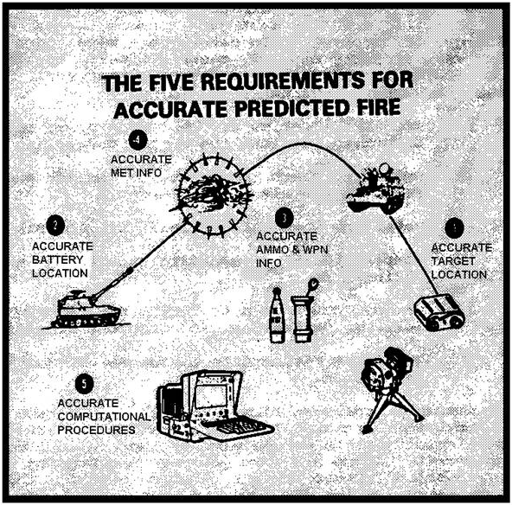

Figure 1-3. The five requirements for accurate predicted fire.

(1) A target of opportunity is one that is unplanned. Targets of opportunity are normally fleeting in nature and are attacked immediately if they pose a threat to friendly forces. When more lucrative targets must be attacked or fire support resources are limited, targets of opportunity may just be recorded. The decision to attack or ignore targets of opportunity is made at the maneuver force command level most likely to be affected. Even though FFE is the preferred method of fire, AF is sometimes necessary and would most likely be employed when engaging a target of opportunity.

(2) A planned target is one on which fire is prearranged. Planned targets are subdivided into either scheduled or on-call targets.

• A scheduled target is one on which fire is to be delivered according to a time sequence. A
Preparation is an example of a scheduled target, since it is fired at a specific time in relation
to H-hour (the time that our forces start an operation--usually an attack.)

• An on-call target is to be fired on request rather than on a specific time schedule. An on-call target reduces the reaction time to initiate fire. Examples of on-call targets are priority targets such as final protective fires (FPF), copperhead, or suppression targets. Firing units will lay on priority targets when they are not engaged in other missions.

The complexity of preparing to fire on planned targets may vary from a simple plot on the firing chart (properly identified with a target number, target description, and other technical firing data) to complete scheduling, grouping, and programming. Sweep and zone fires are methods of attack on a planned target that require extensive analysis, computation, and preparation by both the FDC and the howitzers. The sweep and zone method of fire is used to cover a large area target with a limited number of firing elements. The execution of sweep and zone fires is time consuming, requires large quantities of ammunition, and removes the element of surprise after the first volley is fired.

4. Components of the FA System

Firing procedures must be orderly, organized, and coordinated to be effective. All elements of the gunnery team (fire support team [FIST], FDC, and firing sections) must be responsive to the needs of the supported maneuver force. Streamlined calls for fire, FDC procedures, and fire commands enhance responsiveness. To achieve the desired results--timely defeat of enemy elements--key platoon and battery personnel must understand these procedures.

a. The gunnery problem. Field artillery weapons can engage targets at great range. Cannons normally emplace in defilade positions to be concealed from enemy observation and protected from direct fire weapons. This placement usually precludes sighting the weapon directly at the target (direct fire-see Para 7). To attack a target, cannons employ indirect fire. The gunnery problem is to determine aiming and ammunition data that, when properly applied, ensures timely, accurate, and effective fire on targets not "seen" by the howitzers. The steps in solving the gunnery problem are as follows:

(1) Know the location of the firing unit, and determine the location of the target.
(2) Determine chart (map) data (direction and range from the weapons to the target).
(3) Determine vertical interval (VI) and site (SI).
(4) Compensate for nonstandard conditions that affect firing data.
(5) Convert chart data to firing data (charge, fuze setting, deflection, and quadrant elevation).
(6) Apply the firing data to the weapon and ammunition.

b. Accurate predicted fire. To achieve accurate first-round FFE on target, an artillery unit must compensate for nonstandard conditions as completely as time and the tactical situation permit. There are five general requirements for accurate predicted fire to achieve first-round FFE. These requirements are:

(1) Accurate target location and size.
(2) Accurate firing unit location.
(3) Accurate weapon and ammunition information.
(4) Accurate meteorological information.
(5) Accurate computational procedures.

If these requirements are met, the firing unit will be able to deliver accurate and timely fires in support of the ground gaining arms. If these requirements cannot be met completely, the firing unit may be required to use adjust-fire missions to engage targets. Adjust-fire missions result in less effect on target, increased ammunition expenditure, and a greater possibility that the firing unit will be detected. An alternative to adjust fire is registering. Registering enables the unit to compensate for non-standard conditions and determine accurate firing data to regain first round FFE capability. Even so, a registration will not correct for inaccuracies in target location from mission to mission. Before a registration is conducted, the value of accuracy must be weighed against the vulnerability of the firing unit.

c. The gunnery team. The field artillery gunnery problem is solved through the coordinated effort of the gunnery team employing the field artillery system (Fig 1-4). The gunnery team consists of the fire support team (FIST), the fire direction center (FDC), and the firing battery linked by an adequate communications system.

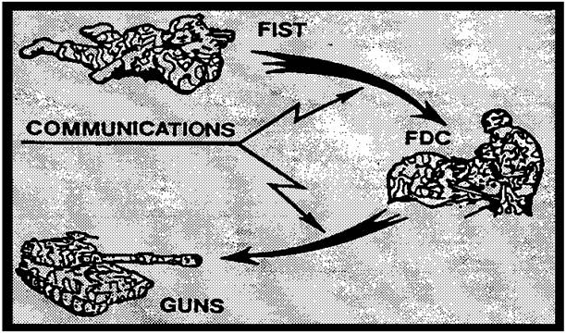

Figure 1-4. The field artillery gunnery team.

(1) OBSERVER: Personnel assigned to a Fire Support Team function as observers. The observer serves as the "eyes" of the artillery. An observer detects and locates suitable indirect fire targets within his zone of observation. To attack a target, the observer transmits a request for fire to the FDC. He adjusts fire onto the target when the five requirements for accurate predicted fire have not been met and a registration has not been conducted. Every effort is made to bring effective fire onto a target with the first round(s), by careful planning of fires. The company fire support officer (FSO) plans fires together with the maneuver company/team commander rather than waiting for a target to become an active threat. He then submits a target list (Fig 1-5) to the FDC, where technical fire direction is accomplished (See note on page 1-17). Information submitted includes:

• Target number.

• Description.

• Location.

• Remarks (as appropriate).

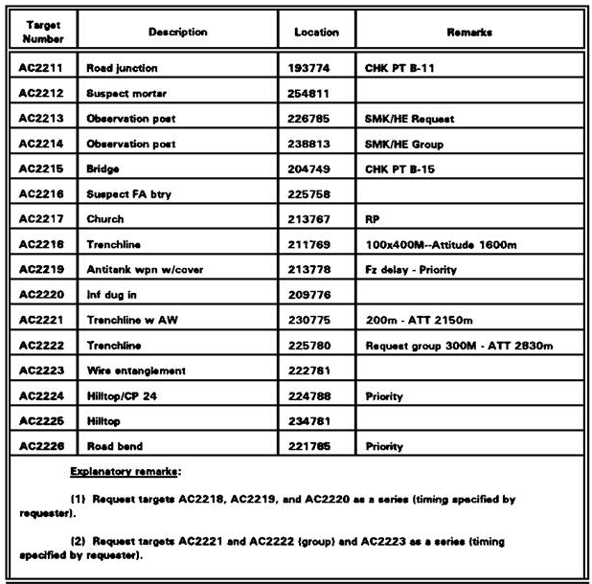

Figure 1-5. Example FIST target list.

(2) FIRE DIRECTION CENTER: The fire direction center (FDC) is the "nerve center" or "brains" of the field artillery system. The FDC receives the call for fire from the observer, plots the target location on the firing chart (Fig 1-6), determines chart and firing data and converts this data to fire commands. Fire commands are then transmitted to the sections designated to fire the mission. While the battery FDC conducts technical fire direction, the battalion FDC normally provides tactical fire direction, monitors all radio fire nets, and provides technical fire direction assistance to battery fire direction centers.

NOTE: 1. Technical fire direction is the process of converting weapon and ammunition characteristics (muzzle velocity, propellant, temperature, and projectile weight), weapon and target locations, meteorological information to firing data. The results are the computation of fuze setting, charge, deflection, and quadrant elevation.

2. Tactical fire direction includes processing calls for fire and determining the appropriate fire method, ammunition expenditure, unit(s) to fire, and time of attack.

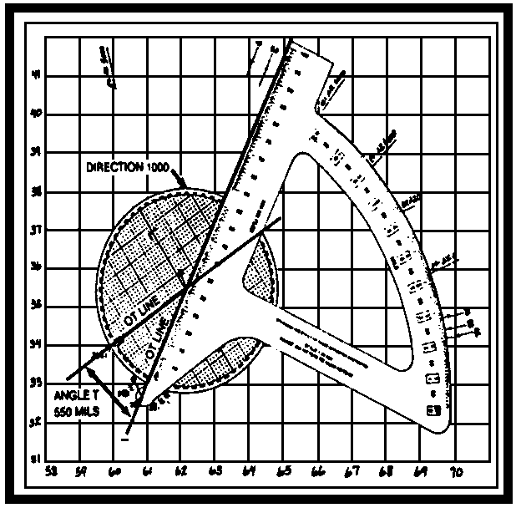

Figure 1-6. Firing chart.

(3) FIRING BATTERY: The firing elements of the battery deliver the punch and serve as the "brawn" of the artillery system. The firing battery consists of the battery headquarters and six or eight howitzer sections. The normal function of the howitzer section is to deliver fire as directed by the fire direction center.

5. Battery FDC--Mission Processing

In the battery FDC, all actions are oriented toward timely and accurate computation and transmission of fire commands. To ensure responsiveness, FDC personnel are trained to accomplish many operations simultaneously. The FDC is configured so data is processed and exchanged quickly and efficiently. Communication equipment is positioned so all personnel hear the call for fire. Personnel who exchange information should be facing or next to one another, as illustrated in Figure 1-7.

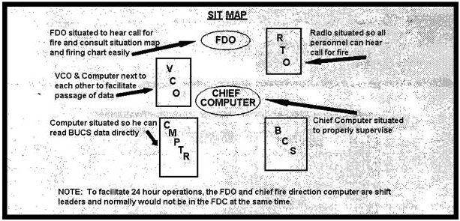

Figure 1-7. Battery FDC--recommended arrangement.

The Battery Computer System (BCS) is the primary method of determining firing data. The Back Up Computer System (BUCS) is the primary method of computing firing data when the BCS is inoperative, or in units with no BCS. In a TACFIRE equipped battalion, voice communications are usually not required. The observer's fire request is transmitted digitally from his digital message device (DMD) through TACFIRE, to the Battery Computer Unit (BCU). Battalion TACFIRE provides the tactical fire direction and the BCU at battery level computes the technical firing data. When TACFIRE is fully operational, 80%-90% of fire missions received will come from TACFIRE. In a non-TACFIRE equipped battalion, the observer's request is transmitted directly to the BCU. This is known as operating in an autonomous mode. Necessary overrides to comply with the fire order are entered into the BCU, which then computes the firing data. The data is transmitted digitally to the howitzer's Gun Display Unit (GDU).

a. BCS/BUCS Mission Processing (Fig 1-8): The following is a sample mission being processed at the battery FDC with the BCS/BUCS. The call for fire (CFF) is received directly (digitally or voice) in the battery FDC from the FIST. (Autonomous mode)

(1) "T36 THIS IS T49, ADJUST FIRE, OVER." (Call for fire)
(2) The BCS operator (radiotelephone operator [RATELO]) announces "FIRE MISSION" to the FDC. The computer immediately transmits/announces "FIRE MISSION" to the guns.
(3) The RATELO continues to read back the FIST's call for fire, ensuring he has proper authentication: "GRID 459286, OUT--INFANTRY PLATOON DIGGING IN, ICM IN EFFECT, AUTHENTICATE LIMA ZULU, OVER--ROGER OUT."
(4) The other members of the FDC monitor the call for fire.

• The computer operator enters the grid into BCS/BUCS.

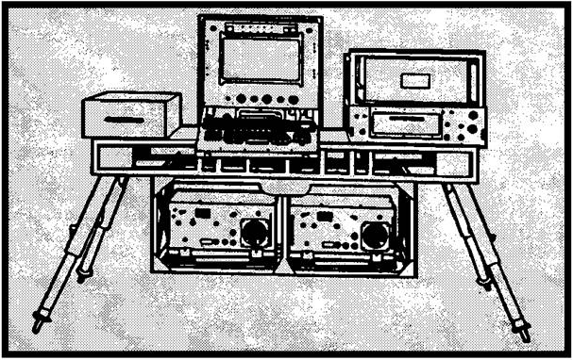

Figure 1-8. BCS.

If voice, the Vertical Control Operator (VCO) plots the target on the map and determines and announces the altitude.

• The FDO inspects the target plot on the situation map and firing chart.

(5) The battery FDO determines his plan of attack (based on commander's guidance and other fire order considerations) and announces his fire order: "3 ROUNDS, VT IN EFFECT."

(6) The fire order triggers several simultaneous actions:

• The computer operator enters appropriate overrides and computes data with the BCS/BUCS.
• The computer reads the entries on the BCS screen for the FDO or chief computer to verify. Once verified, the computer executes the mission and determines firing data.
• All fire commands are verified against current safety data.
• The computer transmits/announces initial fire commands (up to fuze setting) to the howitzers.
• The RATELO determines and transmits/announces the Message to Observer (MTO) and receives Observer-Target (OT) direction from the observer.
• The battalion FDO, who has monitored the mission, checks the MTO. If he agrees, he remains silent.

NOTE: The battalion FDO monitors voice CFF when the battery is operating in non-TACFIRE environment. Normally battalion TACFIRE performs all tactical fire control, sends the mission digitally to the battery's BCS, and transmits the MTO to the observer.

(7) When BCS/BUCS data is displayed, the computer transmits the data to the cannon sections.
(8) The computer has determined angle T and announces it to the RATELO. The RATELO sends angle T to the FIST if it is equal to or greater than 500 mils. The computer prepares for manual backup.
(9) When the adjusting piece (Gun #3) fires, "SHOT #3" is announced to the computer, who replies back to gun #3, "#3 SHOT." The RATELO then sends "SHOT OVER" to the observer, and the observer replies "SHOT OUT".
(10) The observer sends his subsequent corrections: "LEFT 60, DROP 100, FIRE FOR EFFECT, OVER."

• The computer operator enters the corrections in BCS/BUCS.
• The FDO or chief computer verifies entries.
• The computer transmits/announces the change in method of fire to the guns.

(11) When BCS/BUCS data is displayed, it is sent to the guns. "SHOT" is sent to the observer when the guns fire.
(12) When a gun has fired three rounds, "ROUNDS COMPLETE" is transmitted/announced to the computer. When all guns have reported, the computer announces "ROUNDS COMPLETE" to the RATELO, who transmits "ROUNDS COMPLETE" to the observer.
(13) If the fires are effective, the observer sends refinement, end of mission, and surveillance to the RATELO.
(14) The FDO announces "END OF MISSION." The Horizontal Control Operator (HCO) determines and announces refinement data and gives (EOM) to BCS/BUCS. The computer transmits/announces "END OF MISSION" to the guns. "END OF MISSION" is also transmitted to the observer.

b. Manual Mission Processing: If the FDC does not have an automatic data processing capability (BCS or BUCS), the sequence of duties is altered (Fig 1-9).

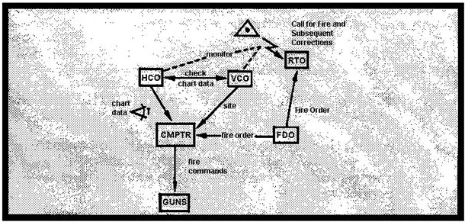

Figure 1-9. Processing the fire mission.

(1) The HCO is the primary chart operator. The HCO plots the target and announces chart range and deflection for the initial grid and for subsequent corrections. He also determines angle T.
(2) The VCO determines site, announces it to the computer when requested, and follows the mission on his chart to provide a positive check on the HCO's data.
(3) Using the graphical firing table (GFT), the computer converts the announced chart data into firing data and sends it to all the howitzers.

c. Processing Planned Targets: Planned targets are targets other than targets of opportunity. Planned targets reduce response time and enhance the element of surprise. Planned targets are either scheduled or on-call targets. Priority targets are designated by the maneuver commander by type, location, or time sensitivity. Processing planned targets in the FDC follows standard FDC procedures, but the execution of the fire mission is controlled to meet specified contingencies:

• Scheduled targets are fired at a time prescribed in the schedule. The time to fire is stated in relation to an H-hour (that is, H + 5 minutes).
• On-call targets are planned to meet a specific contingency. Known points are established on the ground and in the BCS/BUCS to serve as reference points from which to shift fires onto a target.
• Priority targets are also on-call targets. They are established to provide immediate response to a critical development. A Final Protective Fire (FPF) is an example of a priority target.

In each case, the effect on the target is dictated in part by the fuze and projectile combination and the method of fire. The FDO's fire order prescribes these elements.

(1) The FDO ensures the FDC is fully prepared to support the mission of his battery. He must--

• Ensure firing data is computed for all planned targets.
• Specify (based on the priorities established by the requesting FIST) which platoon lays on each of the priority targets (2 maximum. i.e., 2 copperheads or 1 FPF).
• Ensure all maneuver control measures are posted in the fire direction center.
• Monitor the progress of the maneuver elements, and post the movement on firing charts and situation maps during the operation.
• Direct platoons to re-lay on new targets and to prepare ammunition as priorities change and the movement progresses.
• Anticipate the needs of the maneuver force, and be prepared to accept multiple missions.

(2) Battery FDC personnel plot and compute firing data for all planned targets and checkpoints. Priority targets may be assigned on the basis of one per platoon (either copperhead or FPF). Data for priority targets are sent to all howitzer sections. The battery FDO directs individual platoons to lay on specific targets based on priorities established by the maneuver company/team commander and the company FSO. To help in identifying platoon assignments, the top right quadrant of each tick mark is used to indicate the platoon to which that target is assigned. The method of computing firing data for planned targets depends on the amount of time available before the operation begins. Data is computed and double-checked using BCS/BUCS and standard FDC procedures. If time is limited, the data is computed using streamlined procedures.

(3) The use of operational SOPs, fire orders, and fire commands in standardized and streamlined form provides significant reduction in response time.

• A good SOP enhances responsiveness. SOP's should include:
•• amount and type of ammunition for suppression and smoke missions, guidance on the use of minimum safe time for variable time (VT) fuze--armed VT.
•• planned fire orders and fire commands and their use,
•• howitzer section responsibilities for priority targets and preparation of ammunition, and
•• other procedures for doing various tasks

• Fire order and fire command standards are selected on the basis of responsiveness to maneuver forces and the level of training of the FDC personnel.
• The command to fire on a priority target consists of two elements: pieces to fire/method of fire and target number. For example, "RIGHT, SUPPRESS AC7343."

Since the firing data for suppression of a preplanned target is already at the guns, only a cursory command to fire is necessary.

NOTE: The FDC determines firing data for all pre-planned targets. Fire commands for priority targets are sent immediately to the guns with the special instruction, "DO NOT LOAD". Other planned firing data is developed but not sent to the guns until the mission is to be fired. Cannon sections, are always laid on their assigned priority target in

6. Executing the Planned Fire Mission

Planned fire missions are controlled by means of established sequence of fire commands. Fire commands provide the cannon section with all of the information it needs to start, conduct and cease firing. In a battery without BCS, fire commands are sent by voice. If BCS is used, fire commands are sent digitally from the BCU to the gun display unit (GDU) at the howitzer. The initial fire commands include all elements necessary to lay, load, and fire the pieces. Subsequent fire commands include only those elements that are changed, except quadrant elevation, which is always announced. The battery XO/FDO must ensure the FDC and cannon sections understand and use prescribed fire commands.
Certain elements of the fire command may be predestinated as standard. These are pieces to follow, pieces to fire, method of fire, projectile, ammunition lot, fuze, and fuze setting. Fire commands are announced in the following sequence (Fig 1-10).

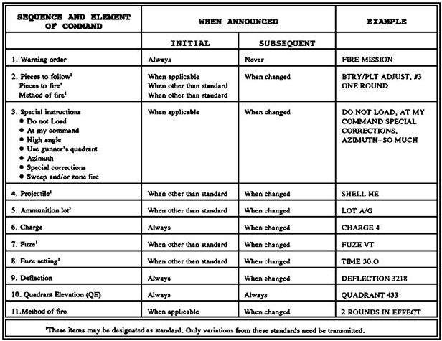

Figure 1-10. Fire Commands.

a. Explanation of fire commands. Fire commands are sent to the guns digitally or by voice. Digital fire commands are used by units equipped with BCS. Fire commands are displayed on the Section Chiefs Assembly (SCA), and deflection and quadrant are displayed on the gunner and assistant gunner's Gun Assemblies (GA), respectively. The COS announces all fire commands (including deflection and quadrant), and listens for the gunner and assistant gunner to read back deflection and quadrant. Voice fire commands are used by units without BCS or when the BCS fails to function. To simplify the use of voice commands, the FDC announces the fire command standards to the COSs when the unit occupies the position. Regardless of the method used to transmit fire commands, the order and elements of those commands remain the same and are as follows:

(1) Warning Order. A warning order is always announced in the initial fire commands to alert the firing unit to the mission. In a BCS equipped unit, the warning order is a steady alarm from the case assembly of the GDU. The COS silences the alarm and acknowledges receipt of the mission by pressing the cycle key on the SCA. When voice commands are used, the warning order is "FIRE MISSION." The warning order is not given in subsequent fire commands.

(2) Pieces to Follow, Pieces to Fire, and Method of Fire. This element designates the weapons to follow the mission, the weapon(s) to fire initially, and how they will engage the target.

• Pieces to follow tells the firing unit who will follow the commands given for the adjust fire-mission. "BATTERY ADJUST" or "PLATOON ADJUST" indicates that the mission will be an adjust-fire mission and all weapons will copy the commands. They will follow the mission and participate in the FFE phase. Several weapons may be announced; for example, "PLATOON ADJUST" or “NUMBER 1 AND NUMBER 3 ADJUSTS." In a BCS equipped unit, the Do Not Load (DNL) indicator bars will be lit on the SCAs of those howitzers to follow the mission. Pieces to follow are not given in a FFE mission.
• Pieces to fire indicate which weapon(s) will fire the data given in the initial fire commands. "PLATOON ADJUST, NUMBER 3" indicates that during an adjust-fire mission, number 3 will fire the initial round of adjustment. In a BCS equipped unit, the SCA of the piece(s) to fire (Number 3 in this example) would show 1 RD ADJ, and the double indicator bars under the word FIRE would light. The voice command is "NUMBER 3," for adjust-fire or "PLATOON" or "BATTERY" for FFE.
• Method of fire tells the firing piece(s) how many rounds to fire. "PLATOON ADJUST, NUMBER 3, 1 ROUND" indicates that during this adjust-fire mission, Number 3 will fire one round at the data given in the initial fire command. "PLATOON 1 ROUND" indicates an FFE mission with all weapons firing one round with the initial fire commands.

(3) Special instructions. Special instructions are used when actions that are different from normal are required. Within the BCS-equipped battery, restrictive commands ("DO NOT LOAD" OR "AT MY COMMAND") are signified by the double indicator bars under DNL or AMC on the SCA. Other special instructions, such as high angle, (use) gunner's quadrant, azimuth, or zone and/or sweep fire, are displayed as digital readouts in the window of the SCA when the special instruction key of the SCA is pressed. When voice commands are used, FDC must announce the special instruction(s) to be followed. It is not necessary to precede a special instruction with the words "SPECIAL INSTRUCTION." However, when more than one special instruction applies, preceding them with "SPECIAL INSTRUCTIONS" will normally reduce any misunderstanding. Unit SOPs and degree of training dictate how this should be implemented.

• "DNL" is a restrictive fire command that prohibits loading and firing. The section may prepare the projectile, charge, and fuze (if applicable); lay the howitzer for deflection; and set the quadrant elevation (or loading elevation).

Digital Double bars are lit under DNL on the SCA. When the round is to be fired, the double bars under FIRE on the SCA are lit and the audible alarm sounds. The section chief announces "CANCEL DO NOT LOAD, QUADRANT (so much)." The howitzer is fired at the section chief's command unless otherwise restricted.

Voice The command from the FDC would be "(so many) ROUNDS, (SPECIAL INSTRUCTION) DO NOT LOAD." To fire the rounds, the FDC commands "CANCEL DO
NOT LOAD, QUADRANT (so much)." This command allows the guns to load if not otherwise restricted by special instructions. The target number may be used in place of the command
"QUADRANT" to allow loading and firing of planned targets and scheduled fires. "DO NOT LOAD" does not apply to the entire mission. It must be announced with each initial or subsequent command.

NOTE: "DO NOT LOAD" is a standard special instruction in a Copperhead priority mission. The Copperhead target of opportunity mission is "AT COMMAND."

• "AT MY COMMAND (or BY PIECE [BY ROUND] AT MY COMMAND)" is a restrictive command that prohibits the battery from firing until directed to do so by the FDC.

Digital Double bars under AMC on the SCA are lit. When the section is laid, the section chief presses the READY key at the SCA. When the round is to be fired, the double bars under FIRE light and the alarm sounds.

Voice-The command from the FDC would be "(so many) ROUNDS, (SPECIAL INSTRUCTION) AT MY COMMAND." When directed to fire the rounds, the section(s) would fire all of the rounds specified in the method of fire. The command "BY PIECE AT MY COMMAND" would direct the sections to fire all the rounds specified in the method of fire by section(s) as announced by the FDC. The command "BY ROUND AT MY COMMAND" would direct the section(s) to fire each of the rounds in the method of fire by volley as commanded by the FDC. The command "BY PIECE, BY ROUND, AT MY COMMAND" combines the control of both commands explained above. "AT MY COMMAND" remains in effect until the FDC commands "CANCEL AT MY COMMAND" or BY
PIECE or BY ROUND AT MY COMMAND "AT MY COMMAND" may be canceled at any time. If the FDC has announced QUADRANT, the command would be "CANCEL AT MY COMMAND, QUADRANT (so much)." "HIGH ANGLE" is announced, or displayed as HA on the SCA, to alert the section that the mission is to be fired at an angle of elevation greater than 800 mils. Light artillery weapons can be elevated before loading. Medium and heavy artillery weapons must be loaded at loading elevation. "USE GUNNER'S QUADRANT" is announced, or displayed as GQ on the SCA, when the FDC wants the gunner's quadrant to be used to set or check quadrant elevation. This is more often used in firing an danger close or precision fire mission, which requires greater accuracy. "AZIMUTH" is announced, or displayed as AZ on the SCA, to alert the sections to a large shift in the direction of fire. The command "AZIMUTH" is followed by the azimuth in mils. "SWEEP (so many) MILS, (so many) DEFLECTIONS" commands a method of fire used when the standard sheaf does not adequately cover the target and more width is required. Sweep fire provides for firing several deflections with one quadrant.

Digital-A sample SCA display for sweep fire is S 10m5DF, which indicates sweep 10 mils, 5
Deflections

Voice-A sample command is "SWEEP 10 MILS, 5 DEFLECTIONS." The COS computes the required deflections and, after firing the displayed deflection, fires the remaining deflections in any
Order or as directed by SOP

EXAMPLE:

The SCA displays S 15m 3DF and a deflection of 3231. The section chief computes deflections 3216 and 3246 by subtracting 15 mils from and adding 15 mils to the displayed deflection (Figure 1-11). After firing the displayed fire commands as deflection 3231, the section chief directs the crew in firing the computed deflections in any order. Sweep fire always includes an odd number of deflections to be fired.

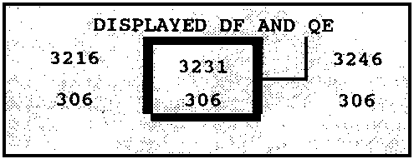

Figure 1-11. Computations for sweep fire.

"ZONE (so many) MILS, (so many) QUADRANTS commands a method of fire used when the standard sheaf does not adequately cover the target and more depth is required. Zone fire provides for firing one deflection with several quadrants.

Digital- A sample SCA display for zone fire is Z 5m3QE; i.e., zone 5 mils, 3 quadrant elevations.

Voice- A sample command is "ZONE 5 MILS, 3 QUADRANTS." The section chief computes the required quadrants, fires the initial quadrant, and then fires the remaining quadrants in any order or as directed by unit SOP.

EXAMPLE:

The SCA displays Z 10m 3QE and a quadrant elevation of 409. The section chief computes quadrants 399 and 419 by subtracting 10 mils from, and adding 10 mils to the displayed quadrant (Figure 1-12). After firing the displayed fire commands at quadrant 409, the section chief directs the crew in firing the computed quadrants in any order. Zone fire always includes an odd number of quadrants to be fired.

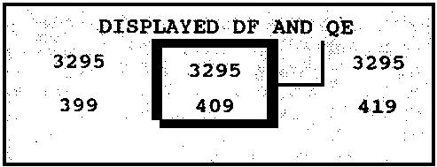

Figure 1-12. Computations for zone fire.

• "SWEEP (so many) MILS, (so many) DEFLECTIONS; ZONE (so many) MILS, (so many) QUADRANTS" commands a method of fire combining sweep fire and zone fire. Sweep and zone fire provides for firing several deflections and quadrants. On the SCA, the command is displayed in the order listed above as the chief of section presses the cycle key (that is, S mDF, ZmQE). The COS fires the displayed commands for deflection and quadrant first and then fires all combinations of computed deflections and quadrants in any order or as directed by unit SOP.

EXAMPLE:

The SCS displays 3RD FFE, S 10m3DF, Z 4m3QE, DF 3200, and QE 310. The chief of section computes deflections 3190 and 3210 and quadrants 306 and 314 (Figure 1-13). After the displayed commands for deflection and quadrant (DF 3200, QE 310) are fired, each of the remaining quadrants is fired with each deflection, for total of 27 rounds (9 deflections and quadrants multiplied by 3 rounds per deflection and quadrant.)

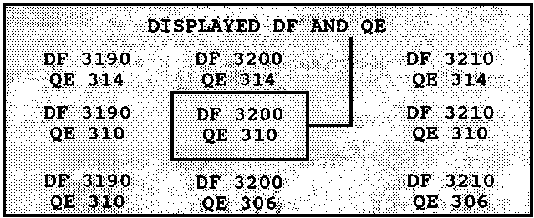

Figure 1-13. Computations for sweep and zone fire.

• “SPECIAL CORRECTIONS" is announced to alert the crew when a separate time, deflection, and/or quadrant will be sent to or fired by one or more gun sections. The words "SPECIAL CORRECTION(S)" should precede any special corrections that apply in the fire command. This command prevents misunderstanding and unnecessary repetition of missed special corrections. If SPECIAL CORRECTIONS is announced alone, it alerts the sections that separate data will be sent to one or more sections. Unit SOP and degree of training dictate how this should be implemented.

• “SPECIAL CORRECTION, NUMBER (so-and-so), LEFT or RIGHT (so many mils) may be announced. Special corrections are applied by the specified piece to the announced deflection and remain in effect until changed (within a fire mission) or until the command "END OF MISSION" is given. This command may be given administratively, apart from fire commands; or announced in the special instructions element of a fire command. These corrections are in addition to any corrections currently on the gunner's aid.

• “SPECIAL CORRECTION, ON NUMBER (so-and-so), OPEN or CLOSE (so many mils) may be announced. Each piece (other than the piece specified) applies a correction to the announced deflection on the gunner's aid. Each section chief determines his correction by multiplying the number of announced mils by the number of pieces his piece is removed from the piece announced. For example, the command "ON NUMBER 3, CLOSE 4" is given. Number 3 applies no correction. Number 1 applies left 8. Number 2 applies left 4. Number 4 applies right 4. All guns fire the announced deflection after applying their corrections to their gunner's aids. These corrections are applied to any correction already on the gunner's aid and remain in effect until changed (within a fire mission) or until the command "END OF MISSION" is given.

• “SPECIAL CORRECTIONS, (LEFT, CENTER, or RIGHT) SECTOR" is announced when Terrain Gun Position Corrections (TGPC) for other than the primary sector are being used. If TGPCs are computed, the corrections for the primary sector are set on the gunner's aids of all the weapons. These corrections are announced administratively and recorded on the DA Form 5212-R. To change sectors, the FDC commands (LEFT, CENTER, or RIGHT) SECTOR. Upon termination of the mission, the howitzer sections reapply the corrections that were in effect before the mission.

• CANCEL TERRAIN CORRECTIONS indicates that all howitzer sections are to set their gunner's aid counters to zero. At the end of the mission, the TGPCs that were in effect before the mission (usually the primary sector) will be reapplied unless the FDC instructs otherwise.

(4) Projectile. This element designates the type of projectile to be used in the fire mission. The type of projectile that is to be prepared and loaded is always displayed in the SCA. When voice fire commands are being used, the projectile must be announced when it differs from standard.

(5) Ammunition Lot. This element indicates the projectile-propellant lot to be fired. The lot number is announced in the initial fire commands unless a specific lot has been designated standard. The lot number is not repeated in subsequent commands unless a change is desired. Separate-loading ammunition has two designators--the first letter for the projectile and the second letter for the propellant. For example, the command "LOT XY," X indicates the projectile lot and Y indicates the propellant lot. Semi fixed ammunition has only a one-letter designation which pertains to the assembled round. The XO must ensure sections segregate ammunition by lot and maintain accurate records of the number of rounds on hand by lot number.

NOTE: Large-quantity lots are set aside to be fired during registrations and missions when more uniform effect is important. Small-quantity lots are used for missions when uniform effect is not critical. Each section will segregate ammunition by lot and keep accurate records on DA Form 4513.

(6) Charge. The charge indicates the amount of propellant to be used and grants permission for the crew to cut the propellant. Charge is automatically displayed in the SCA or announced by the FDC. It is never standardized.

(7) FUZE. The required fuze type is announced (for example, "FUZE TIME") or displayed in the SCA. The section chief announces the fuze displayed on the SCA. Fuze is announced in subsequent commands only when a change in type is desired.

NOTE: The BCU and GDU do not distinguish between M564 and M582 Mechanical Time Super quick (MTSQ) fuzes displayed on the SCA. Unit SOPs will establish what to do if both fuzes are used for the same mission.

(8) FUZE SETTING. If fuze quick is to be fired in the delay mode, "DELAY" is announced by the FDC or displayed on the SCA. If the fuze is a mechanical time (MT), MTSQ, or proximity (VT) fuze, the fuze setting is displayed automatically on the SCA. Voice commands are announced; for example, "FUZE TIME, TIME 17.6 or FUZE VT, TIME 17.0.

NOTE: If shell DPICM is to be fired in the self-registration (SR) mode, fuze setting black triangle (-) 98.0 must be announced; for example, "SHELL DPICM - SR, LOT DG, CHARGE 4, FUZE TIME, TIME BLACK TRIANGLE 98.0."

(9) DEFLECTION. With voice commands, deflection is always announced as four digits; for example, "DEFLECTION 0321" (zero three two one) and "DEFLECTION 3300" (three three hundred).
Normally, deflection is displayed on the SCA as a four-digit value. If three numbers appear, assume the first number is a zero. The section chief announces deflection by using four numbers. The gunner sets the announced or displayed deflection on the pantel and traverses the tube until he has a correct sight picture on the proper aiming point (two-step deflection method). When the section chief announces deflection, the gunner reads back the deflection. After the Assistant Gunner (AG) has reported "QUADRANT (so much), SET," the gunner verifies his sight picture, ensures that his bubbles are centered, and reports "DEFLECTION (so much), READY."

(10) QUADRANT ELEVATION. Quadrant elevation gives the section chief permission to load and fire the round unless otherwise restricted by special instructions or unsafe conditions. The AG sets off the quadrant elevation announced by the FDC or displayed on his gun assembly (for example, "QUADRANT 318)." He elevates the tube to that quadrant elevation after the projectile has been loaded. When the COS announces quadrant, the AG reads back the quadrant that is set on the range quadrant. After the AG has centered the bubbles on the range quadrant, he reports "QUADRANT (so much), SET." To increase responsiveness, loading procedures may be changed per the unit SOPs as follows:

• Round is loaded on deflection. This procedure can be used when loading will not interfere with receipt of the remaining fire commands.

• Adjusting piece loads subsequent rounds immediately after firing. This loading method can be used for all projectile-fuze combinations not using a mechanical time fuze. The adjusting piece may not have the correct projectile-fuze combination loaded when entering FFE. If this occurs, the loaded round is fired and the remaining FFE rounds are fired with the correct projectile-fuze combination. At the end of the mission, the COS reports to the FDC that his howitzer fired ammunition not specified in the fire command.

EXAMPLE:

The fire command was "3 ROUNDS VT IN EFFECT." Number 4 fired one round with fuze quick and two rounds with fuze VT/. The chief of section reports "NUMBER 4 FIRED 1 QUICK AND 2 VT IN EFFECT." The FDC updates the ammunition count accordingly.

CAUTION

DO NOT LEAVE A ROUND IN A HOT OR WARM TUBE FOR A PERIOD LONGER THAN THAT SPECIFIED BY THE TECHNICAL MANUAL FOR THE WEAPON.

• No adjusting pieces load the shell to be fired in effect on receipt of the initial fire command. This procedure also applies to all projectile-fuze combinations not using a MT or VT fuze. When fuze VT is to be fired in effect, the FDC calculates the VT fuze setting corresponding to the initial target location and sends it to the not adjusting pieces. If terrain, weather, and enemy capabilities permit, the FDC can, in wartime, send the VT minimum safe time to the not adjusting pieces.

NOTE: If a howitzer has automatically reloaded during the adjust phase and "END OF MISSION" is announced before the FFE phase, the following precautions should be taken:

• Leave weapon laid on last fired data.
• Announce to FDC "NUMBER (so-and-so) IS LOADED."
• Evaluate hot or cold tube situation.
• Decide to compute safe data to fire round, or unload weapon.
(11) METHOD OF FIRE FOR EFFECT. This element indicates the number of rounds and type of ammunition to be used in effect. When applicable, it is announced in the initial fire command after quadrant and must be announced before the last subsequent command in an adjust-fire mission and is displayed automatically on the SCA. With voice commands, it is announced after quadrant elevation; for example, "2 ROUNDS, VT IN EFFECT."

(12) SPECIAL METHODS OF FIRE. Some voice fire commands cannot be displayed on the GDU SCA. Shown below are the commands and their definitions.

• CONTINUOUS FIRE is given when you want the howitzer crews continue to fire within the prescribed rates of fire for their howitzers until the command "CHECK FIRING or CEASE LOADING" is given.

• FIRE AT WILL is used in a direct-fire role, primarily for perimeter defense. The command is "TARGET (so-and-so), FIRE AT WILL." Howitzer crews fire under the control of their section chief.

(13) CHECK FIRING. The command "CHECK FIRING" may be given by anyone, but it should be used only in emergencies or if a safety violation is noted. All firing ceases immediately. The command may be given by voice, displayed on the SCA, and/or given by hand signals all at the same time. Immediate action must be taken to determine the nature of the check fire and to correct the situation.

NOTE: To give the check firing hand signals, raise your hand in front of your forehead, palm to the front, and swing your hand and forearm up and down several times in front of your

(14) CEASE LOADING. The command "CEASE LOADING" allows the firing battery to fire rounds that have already been loaded, but no additional rounds may be loaded. It is a voice command only, with the exception of FPF missions processed with BCS.

(15) END OF MISSION. The command "EOM" means that the fire mission has been terminated. The howitzer sections should return to the azimuth of lay or priority target data. The SCA displays EOM for that howitzer; for example GUN (number so-and-so) EOM.

(16) PLANNED TARGETS. The battery may be assigned planned targets for which current firing data must be maintained. Each target is assigned a number, and each weapon is laid on its assigned priority target. In such cases, unit SOP usually designates a command or a prearranged signal to fire on the priority target, bypassing the usual sequence of fire commands.

EXAMPLE:
Target AC7343 has been designated as a priority target. Firing data have been computed and have been transmitted to one of the firing platoons. On the command "RIGHT, SUPPRESS AC7343," the right platoon engages Target AC7343 with the previously arranged method of fire.

In defensive operations, the command "FIRE THE FPF" causes the firing battery to fire the FPF on which it is laid.

(17) REPETITION AND CORRECTION OF FIRE COMMANDS. One section (normally the adjusting piece) of the firing unit should be designated to read back all voice fire commands to ensure that the howitzer sections have received the commands correctly. When a command has not been heard or has been misunderstood, the request for repetition is stated as a question; for example, "DEFLECTION NUMBER 2?" When the FDC replies, the repetition of a command is always preceded by "NUMBER so-and-so), THE COMMAND WAS;" for example, "NUMBER 2, THE COMMAND WAS DEFLECTION 2768." If an incorrect command has been given but the command "QUADRANT" has not been announced, the FDC commands "CORRECTION," followed by the correct command and all subsequent elements. If "QUADRANT" has been announced, the FDC commands "CHECK FIRING." "CANCEL CHECK FIRING" is announced, followed by the corrected element and all subsequent elements.

(18) FIRING REPORTS. The section chief reports to the FDC all actions that affect the firing of his weapon in support of the battery mission. During firing, the following specific reports are made:

• When the special instruction "DO NOT LOAD" has been commanded by the FDC, the section chief reports "LAID, NUMBER (so-and-so)." This report is sent when the projectile, charge, and fuze (if applicable) have been prepared; the howitzer has been laid for deflection; and the quadrant (or loading elevation) has been set.

• When the special instruction "AT MY COMMAND" or "BY PIECE (or BY ROUND) AT MY COMMAND" is ordered by the FDC, the section chief reports by voice "READY, NUMBER (so-and-so)." This report is sent when the section is ready to fire (in compliance with the fire command). The report is sent digitally by pressing the READY key on the SCA.

• In voice operations, "SHOT NUMBER (so-and-so)" is reported after each round has been fired. If, however, the method of fire is more than one round, "SHOT" is announced only after the initial round. For GDU-equipped howitzers, the report is sent digitally when the section chief presses the SHOT/RC key on the SCA once.

• “ROUNDS COMPLETE NUMBER (so-and-so)" is announced when the final round specified in the method of fire has been fired. If however, only one round is to be fired, "ROUNDS COMPLETE" will not be reported after "SHOT." For GDU-equipped howitzers, the report of rounds complete (RC) is sent when the SHOT/RC key on the SCA is pressed a second time. For a GDU-equipped howitzer to receive subsequent fire commands in any mission, rounds complete must be reported to the FDC.

• “MISFIRE NUMBER (so-and-so)" is announced when a misfire has occurred (voice only).

• Ammunition status is reported. The number of rounds expended, by type and lot number, is reported when requested by the FDC (voice or per unit SOP).

• Errored data fired--the chief of section reports to FDC the actual data fired in error; for example, "NUMBER 2 FIRED DEFLECTION (so much)."

(19) STANDARDIZING ELEMENTS OF THE FIRE COMMAND. Certain elements of fire commands may be standardized after the tactical situation; weapon and personnel capabilities, ammunition status, and enemy counterfire threat have been considered. As shown in Figure 1-10, the following elements of the fire command may be designated as standard: pieces to follow, pieces to fire, method of fire, projectile, ammunition lot, and fuze. If the FDO decides to vary from fire command standard data, he must administratively cancel the existing standard and issue the replacement standard data. Only one set of standard data can be in effect at any particular time. Once standards are placed in effect, the platoon will fire the standard data unless the fire command specifies otherwise.

EXAMPLE:
The FDO or platoon leader considers the tactical situation and the other factor mentioned above and determines the fire command elements designated as standard should be as follows:

• Pieces to fire and method of fire: Number 3, 1 round.
• Projectile: HE.
• Ammunition lot: XY.
• Fuze: Quick.

These standards tell the firing unit that if not stated in a fire command, the piece to fire will be Number 3 and the method of fire will be one round, shell HE, lot XY, and fuze quick.

(20) EXAMPLES OF FIRE COMMANDS.

• Nonstandard Adjust-Fire Mission. In this example, no standard elements are used.

"FIRE MISSION, PLATOON ADJUST, NUMBER 3, 1 ROUND, SHELL HE, LOT XY, CHARGE 4, FUZE QUICK, DEFLECTION 3024, QUADRANT 247, 2 ROUNDS IN EFFECT."

Number 3 is announced as the adjusting weapon. It fires one round (shell HE, lot XY, fuze quick) with the announced charge and at the announced deflection and quadrant. The rest of the platoon prepares two HE rounds with fuze quick and follows the fire mission.

The first subsequent fire command is as follows:

"DEFLECTION 2978, QUADRANT 218."

Number 3 fires one round (shell HE, lot XY, charge 4, fuze quick) at the new deflection and quadrant.

The second subsequent fire command is as follows:

"PLATOON 2 ROUNDS, DEFLECTION 2950, and QUADRANT 210."

The entire platoon fires two rounds at the announced deflection and quadrant. "END OF MISSION" is commanded as appropriate.

Nonstandard FFE Mission- In this example, no standard elements is used.

"FIRE MISSION, NUMBER 3 AND NUMBER 4, 3 ROUNDS, SHELL WP, LOT DY, CHARGE 7, FUZE QUICK, DEFLECTION 2870, QUADRANT 320."

Number 3 and Number 4 each fires three rounds as commanded. "END OF MISSION" is commanded as appropriate, and ammunition expended is updated.

Standard Adjust-Fire Missions- Elements designated as standard in this example are Number 3 firing
one round in adjustment, shell HE, lot XY and fuze quick:

"FIRE MISSION, PLATOON ADJUST, CHARGE 4, DEFLECTION 3024, QUADRANT 247, 2 ROUNDS IN EFFECT."

Number 3 fires one round (shell HE, lot XY) fuze quick) with the announced charge and at the announced deflection and quadrant. Not adjusting pieces prepare two rounds of HE and follow commands. Adjustment continues as in the first example.

When fire for effect is entered, the commands are as follows:

"PLATOON 2 ROUNDS, DEFLECTION 2950, and QUADRANT 210."

The entire platoon fires two rounds of shell HE at the announced deflection and quadrant. "END OF
MISSION" is commanded as appropriate.

• Standard FFE Mission. Elements designated as standard in this example are Number 3, one round, shell HE, lot XY, and fuze quick:

"FIRE MISSION; PLATOON 3 ROUNDS, CHARGE 4, DEFLECTION 3111, QUADRANT 400."

Each weapon in the platoon fires three rounds (shell HE, lot XY, fuze quick) with the announced charge and at the announced deflection and quadrant. "END OF MISSION" is commanded as appropriate, and ammunition is updated.

b. Example fire commands for planned targets. When the battery is assigned planned targets, they must be processed quickly and readied for immediate response. Scheduled and on-call target information and firing data are stored at the FDC until just before firing. Therefore, they are executed by the firing elements much like any other mission. For example, the initial method of fire "BATTERY 3 ROUNDS" and/or "AT MY COMMAND" is announced in the case of a scheduled or time-on-target (TOT) missions. Then, at a predetermined time, the FDC commands "FIRE." However, firing data (fire commands) for priority targets, such as "SUPPRESSION" or "FPF" are sent to the howitzers immediately. The following examples illustrate firing procedures for each type of fire mission on planned targets. "FIRE FOR EFFECT" is the method of fire.

(1) On-call targets are planned on suspected enemy locations and prominent terrain features. They serve as known points that allow shifting fires to targets of opportunity. The battery FDC receives a target list from battalion FDC. All targets are plotted and properly identified with target numbers.
Technical firing data are developed for each. Their data are further refined as survey control is extended to the battery, registrations are completed, and meteorological (Met) data become available (Met + VE). One of the targets is described as a suspected platoon assembly area. As the operation gets underway, the FIST confirms his suspect target as actual and calls for fire. The FDC alerts the firing battery: "FIRE MISSION." Elements designed as standard in this unit are: number 3, one round; shell HE; lot XY; and fuze quick. The FDC quickly announces the rest of the fire commands: "BATTERY 2 ROUNDS, CHARGE 4, DEFLECTION 3377, and QUADRANT 487." Each weapon in the battery fires two rounds of the standard shell, lot, and fuze at the announced deflection and quadrant.

(2) As with all planned targets, necessary information for scheduled targets is given to the battery FDC with as much lead time as possible. FDC converts this into technical firing data, updating and refining it as other data becomes available. Scheduled targets are attacked at a specific time, and Time on Target (TOT) is the method of control used by battalion FDC. This ensures the rounds of widely separated batteries impact in the target area simultaneously for maximum effect and surprise. Battalion FDC specifies the actual time in which the rounds are to impact as, "TIME ON TARGET 0915." Battery FDCs determine the Time Of Flight (TOF) of the projectile, add 5 seconds (reaction time) to the TOF, and subtract this total from the TOT to arrive at a precise time to fire the cannons. Battalion FDC ensures synchronization of watches by giving a time check. Beyond that, the execution of a fire mission on a scheduled target is generally the same for the cannon section. The FDC announces fire commands to the howitzers just before the mission is to be fired, adding the restrictive, "AT MY COMMAND." The battalion FDO decides to mass fires to support a preparation on a large area target. He issues the fire order, which is received by battery FDC, as follows: "FIRE FOR EFFECT, BATTALION, GRID
61723618, ALTITUDE 380, SHELL ICM, LOT ZT, FUZE TIME, FOUR ROUNDS, and TIME ON TARGET 0615."

The battery XO/FDO realizes this is a planned target and part of a preparation schedule to support the maneuver commander's plan of attack, which coincides with the time on target. The FDC personnel plot the target, compute firing data, and send commands to the howitzers as follows: "FIRE MISSION, BATTERY 4 ROUNDS, AT MY COMMAND, SHELL ICM, LOT ZT, CHARGE 6, FUZE TIME 25.6,
DEFLECTION 2988, QUADRANT 366."

Since the special instruction "AT MY COMMAND" was announced, the section chiefs report "READY" and wait until ordered to fire by the FDC. The battalion FDO transmits a time check on the command fire (CF) net: "AT MY MARK THE TIME WILL BE 0610--MARK, OVER." The battery acknowledges with "ROGER, OUT."

The mission is now under battery control. FDC computes the time to fire as follows:

TOF = 26 seconds
Reaction time = 5 seconds
Total = 31 seconds

The total is subtracted from the TOT.
TOT = 0615:00
-TOF +5 = :31
Time to command FIRE = 0614:29

At 0614:29 the firing elements are commanded by the FDC: "BATTERY, FIRE!"

(3) During offensive operations, when the situation is vague but the enemy is thought to have a considerable direct fire capability, suppressive fires are planned to provide maneuver units freedom of action. Suppressive fires are planned on known and likely enemy locations. The direct support battery, especially when functioning in the dedicated role, plans and delivers suppressive fires. The FIST chief submits a list of targets, and the battery FDC computes necessary firing data. As soon as the targets are developed, firing data are assigned to the firing element as numbered priority targets. Normally, each platoon is assigned a suppression mission by target number.

These targets are recorded at each howitzer section, as illustrated in Figure 1-14. In a six-howitzer battery, the right platoon (number 1 and 2 sections) is laid on firing data for the first of the assigned priority targets. It remains ready to immediately re-lay and fire on any of the other priority targets when commanded by FDC. The center platoon a number 3 and 4 sections and the left platoon. They maintain readiness and fire the same as the other platoons. In this case, Sections 1 and 2 form the right platoon. The right platoon is laid on target 43. Two rounds of SHELL HE, FUZE QUICK are prepared but not loaded until the FDC gives the command to fire. The command from FDC to fire is "RIGHT SUPPRESS 43." The section chief commands his crew QUADRANT 402. When "SET" and "READY" are announced, the chief of section commands, "FIRE." If target 54 or 57 is to be attacked by the right platoon, the FDC commands "RIGHT SUPPRESS 54 (or 57)." This command means the right platoon must re-lay and fire the data for target 54 (or 57). Using this method of prearranging priority targets enables the six-gun battery to provide immediate suppressive fires on three targets, in priority, as requested by the supported maneuver command.

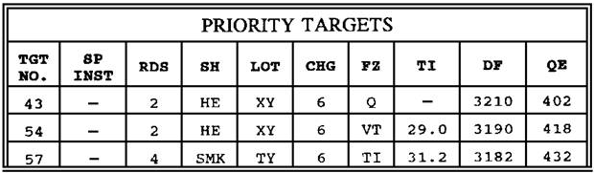

Figure 1-14. Priority targets firing data--right platoon.

(4) Another common type of planned priority target is the FPF. FPFs are immediately available, planned fires, designed to create a barrier to impede enemy movement across defensive lines or areas. These fires are integrated with the maneuver commander's defensive plan. The shape and pattern of FPFs may vary to suit the tactical situation. FPF are normally delivered very close to friendly unit positions. Therefore, planning includes the possibility of firing in each piece of the battery. If METT-T permits the FIST chief adjusts by firing each piece on the desired location. These characteristics of FPFs should be noted:

• Each piece is adjusted individually (when possible), and the chief of section records its final adjusted data.

• The whole battery fires when FPFs are called for. (Method of fire is normally continuous fire.)

• Only one FPF may be assigned to each supporting battery.

An obvious disadvantage to firing in an FPF is the possibility of giving the FPF's location to the enemy. If the five requirements for accurate predicted fire are met, there is minimal advantage to having individual pieces fire in the FPF.

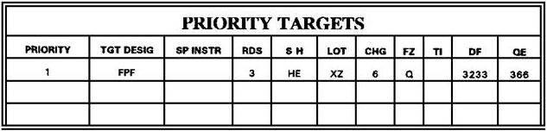

Figure 1-15. FPF target firing data (each gun may differ).

When a call for fire on an FPF area or line becomes necessary, a highly critical and potentially dangerous situation has developed. Immediately responsive and accurate FA fires are essential to the survival of the supported force; Therefore, the battery assigned an FPF must keep each piece laid on the FPF data unless it is engaged in other fire missions. To fire the FPF, the FDC commands "FIRE THE FPF." The sections deliver rounds at the maximum rate of fire until ordered to cease firing by the FDC's command "CHECK FIRING" or "CEASE LOADING."

(5) The command "END OF MISSION" means the fire mission has been completed. All corrections applied to the fire control equipment for that mission are to be removed. Primary terrain gun position corrections are to remain on the appropriate counters unless commanded otherwise by the fire direction center. If a priority target has been assigned, each section lays on the appropriate firing data.

NOTE: The assigned targets may not always be located in the primary sector, so the applicable position corrections (primary, left, right) must be applied to the counters before setting off and laying on assigned target data.

7. Direct Fire

Direct fire procedures are associated with self-defense and forms part of the overall strategy to defend the battery position from an enemy ground attack. Battery or perimeter defense is a plan of action that has one ultimate purpose--to keep the enemy from interfering with the field artillery's primary mission, which is to provide close and continuous fire support to our maneuver forces. When FA cannons cease support in order to defend themselves, the enemy has achieved part of his objective. It is important, therefore, to defend the cannons with every other means available. Supplementary positions are used to enhance the battery defense and supporting the ongoing mission. Supplementary positions can be planned for occupation by anti-tank teams, crew served weapons, and artillery in a direct fire role. Other means available are: Indirect fires from sister platoons/batteries, antitank weapons, mines, machine guns, early warning devices, killer junior, and DPICM. A cannon's direct fire capability should be used in the plan of defense only as a last resort. A multitude of factors must be considered when formulating a plan of defense. Direct fire (direct laying techniques) is one very important aspect. (FA 8001-9, Defense of the Field Artillery Battery, provides a detailed explanation of the fundamentals of defense planning, preparation, and implementation.)

a. Special considerations. Direct laying is a special firing battery technique that requires extensive training and preparation. Proficiency, once acquired, must be maintained and refined by integrating direct fire drills into other firing battery training. Direct fire must be stressed so reactions of the entire cannon crew become automatic, swift, and sure. When direct fire becomes necessary, the situation is critical. During direct fire operations:

(1) Cannon sections conduct fire as individual units.

(2) Survival of the battery depends upon total proficiency of each member and their performance as a team.

(3) The most dangerous targets are engaged first. The battery leadership must assume positive command and control of the situation.

(4) Field artillery cannons are no match for a tank; first-round kills are a must.

(5) Speed and accuracy are of the utmost importance.

The battery that is unable to effectively employ direct fire will be lost. When the direct fire battle starts, there is seldom time for adjustments or second attempts. Unskilled cannon crews stand little chance in the confused, disorganized situations normally associated with direct fire. Every member of the battery, from the commander to the cannoneers, must bear in mind DIRECT FIRE IS USED AS A LAST RESORT after the location of the battery is detected by an enemy force and the battery is attacked. Preparation is the key to direct fire success. We prepare the cannoneers by training and drilling. We can achieve surprise and control the situation better by preparing the position area defense plan and crew served weapon's range cards for each weapon's sector of responsibility.

b. Range cards. Each howitzer section is assigned a sector of fire (Fig. 1-16) by the plt sgt or 1SG that overlaps with the sectors of weapons on the left and right to provide all-around coverage. Each sector of responsibility is integrated into the overall defensive plan for the battery. The primary purpose of a properly prepared range card is to allow any gunner to fire accurate and controlled fire. The COS, assisted as necessary by the gunner and crew members, is responsible for preparing the range card. Cannon range cards indicate azimuths of the left and right sector limits of a cannon. In addition, range cards show key terrain features as predestinated targets with firing data. The range card, DA Form 5699-R, (Fig. 1-17) consists of two parts: a sketch of the sector of fire containing targets and reference points and a data section that lists data necessary to allow any trained individual to fire the weapon accurately and effectively during periods of reduced visibility.

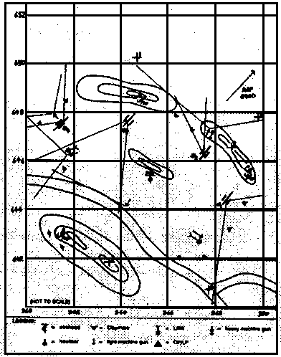

Figure 1-16. Sectors of responsibilities of howitzer sections.

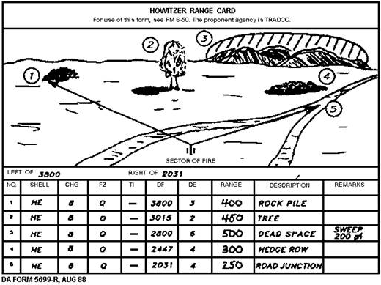

Figure 1-17. Howitzer range card.

The battery also should have a simple directional system that provides a common frame of reference to all sections. One such system is the clock system, in which the battery front is designated as 12 o'clock. Target locations are announced in relation to their positions on the clock, and distance is announced as a range from the battery position to the target. For example: "9 O'CLOCK, 400 METERS."

(1) Two-man, two-sight. This method is best for all weapons except the 155-mm howitzer M102A1 and M119A1/A2. The gunner establishes lead with the panoramic telescope. The AG establishes elevation with the direct fire telescope. This is the fastest and most accurate method of sighting and permits the AG to check the direction of lead. The reticle in the direct fire telescope must be level. A canted reticle in the direct fire telescope prevents satisfactory direct fire on moving targets, because an unacceptable range error is introduced when lead is changed.

(2) Two-man, one-sight. This method is best for the M114A1/A2 and M119. The number 2 cannoneer establishes lead with the panoramic telescope. The AG sets elevation on the elevation quadrant at the command of the chief of section. This method is not effective when the target is moving on other than flat terrain.

(3) One-man, one-sight. This method is least desirable and should not be used unless absolutely necessary. The gunner lays for lead and elevation with the reticle of the panoramic telescope. This method should not be used if the target is moving on a steep slope.

c. Laying. There are two primary methods of laying:

(1) The best method for M12 series sights is reticle laying with deflection zero. The gunner maintains lead by placing the vertical hairline on the proper number of mils ahead of the point of aim on the target (Fig 1-18).

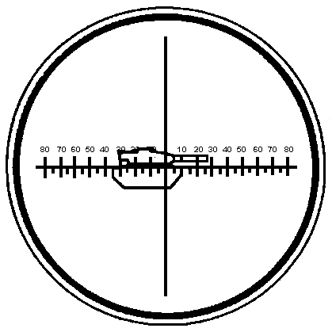

Figure 1-18. Gunner’s sight picture, reticle laying, lead right 10 mils.

(2) The best method for M100-series sights is central laying. The gunner sets the lead in mils on the azimuth micrometer scale of the panoramic telescope and keeps the vertical hairline of the reticle on the center of the target (fig 1-19). A modification on the knob of the M100-series panoramic telescope, called click sights, permits the gunner to set off lead in 5-mil increments, by sound or feel, without removing his eye from the sight.

NOTE: Refer to weapon technical manuals for variations to stated procedures.

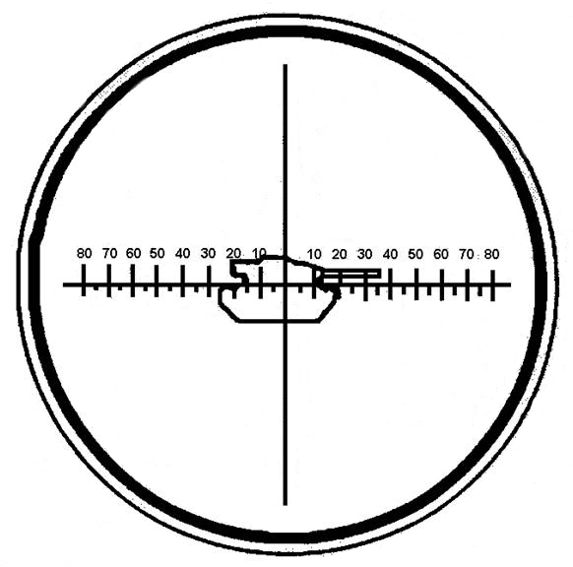

Figure 1-19. Gunner’s sight picture, central laying.

d. Fire commands. The executive officer, as OIC of the firing battery and its chief training officer, ensures direct fire commands are well known and the meaning of each element of the fire command is fully understood by all crew members of each howitzer section. The chief of section must be familiar with direct fire commands. He announces the proper command for a particular situation. When enemy forces threaten our perimeter, action normally is initiated by the battery XO or the senior person present.

(1) To initiate direct fire action, the XO designates:

• Target.

• Pieces to fire.

• Method of fire.

An example of the fire command given by the XO is "TARGET, 2 O'CLOCK, 500 METERS, ONE BMP, NUMBER 1, FIRE AT WILL."

(2) The chief of section determines and announces the necessary fire commands. The gunner commands "FIRE." Elements of fire commands for direct fire are kept brief and precise to ensure proper and immediate response. There are five elements in a direct fire command.

• A warning order--"TARGET" (designation).

• General direction of the target within the howitzer section's sector of responsibility--"LEFT (RIGHT) FRONT."

• Lead in mils (for moving targets)--"LEAD, RIGHT 15" (see Fig 1-20).

• Range to the target (in meters)--"RANGE 500 or QUADRANT" (in mils).

• Method of fire--"FIRE AT WILL."

NOTE: Shell, charge, and fuze should be standardized. If other than standard, they are announced following the target designation ("CHARGE 6, FUZE DELAY")

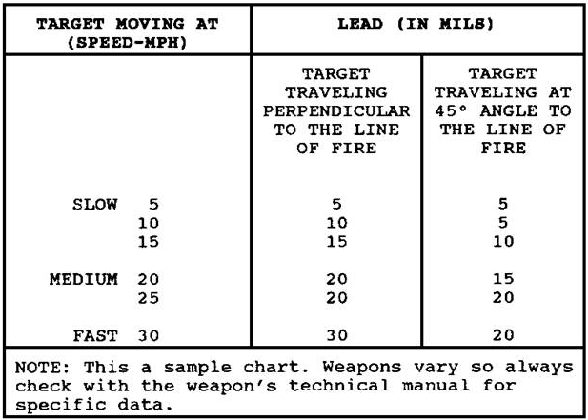

Figure 1-20. Determination of lead--M100 series sight.

The examples of the fire commands given by the XO indicate the chief of section's responses and actions. The XO commands: "TARGET, 2 O'CLOCK, 600 METERS, ONE TANK, NUMBER 1, FIRE AT
WILL."

The chief of section identifies the target and alerts the section to prepare for direct fire. If the target is a group of tanks or other objects, the chief of section selects the one that, in his estimation, is the greatest threat to the battery position. Priorities for selecting targets are:

• First--tanks at short range threatening to overrun the position.

• Second--hull-down, stationary tanks covering the advance of other tanks.

• Third--an area containing enemy troops threatening to overrun the position.

Having selected the appropriate target on the basis of these priorities, the COS estimates the range to the target. Range cards with accurately measured ranges to key points provide the best means for determining the initial range. Estimated ranges are used if accurate measurements are not available. The COS then determines the lead in mils and gives the initial commands to his section: "TARGET, LEAD TANK, MOVING LEFT, SHELL HE, CHARGE 7, FUZE QUICK, LEAD LEFT 10, and RANGE 600."

(Method of fire is "FIRE AT WILL" unless otherwise commanded.)

The COS positions himself where he can best see the effect on the target. He gives subsequent fire commands on the basis of the observed effect.

• Lead--the lead in mils is changed to a new lead command incorporating total lead.

• Range--the range is increased (decreased) by the command ADD (DROP) and the number of meters.

Further changes may be given even after the breechblock is closed. Changes are based on movement of the target during the time required for loading. The actual command "FIRE" is given by the gunner after the AG calls out "SET."

e. Other considerations. Some other points to consider when engaging targets with direct fire are:

(1) The maximum charge should always be used to produce a flat trajectory and high muzzle
Velocity on the basis of Charge 7, 0 to 400 meters is the optimum range to engage targets.
Beyond 1,500 meters, the probability of hits on the target decreases greatly. Beyond 2,500 meters, engaging point targets (vehicles) is ineffective.

(2) It may be more effective to use smoke or WP on certain targets. Antipersonnel and antitank rounds are available for 105-mm howitzers. Fuze DELAY fired in front of troops on hard ground may give a ricochet airburst. Fuze TIME can be effective against troops in direct fire.

8. SUMMARY. The executive officer or platoon leader’s duties during firing are many. As commander and chief trainer of the firing battery, he is responsible for ensuring that all components of the firing battery function effectively. He is the principal fire direction officer responsible for technical and tactical firing data production. Correct firing procedures must be followed during each type of fire mission. Planned targets require prior planning and computation of firing data before the actual time to fire. Sweep, zone, and sweep and zone fires are delivered on targets too large to be covered effectively by other methods of fire. They require a good deal of coordination between the FDC and howitzer section. The howitzer section chief computes the quadrants and the sweeps. Direct fire is a method of fire of last resort and should be undertaken only when necessary. When direct fire must be delivered, the situation is critical. Cannon sections conduct firing as individual units. Preparation, training, drill, and refined procedures must be emphasized if the battery is to survive a direct fire encounter.

LESSON 1

PRACTICE EXERCISE

The following items will test your grasp of the material covered in this lesson. There is only one correct answer for each item. When you complete the exercise, check your answer with the answer key that follows. If you answer any item incorrectly, study again that part of the lesson which contains the portion involved.

1. In a battery based battery, the ______________ normally commands the firing battery portion of the battery.

A. battery commander
B. fire direction officer
C. executive officer
D. platoon sergeant

2. Targets are classified as planned and ____________________.

A. lateral
B. target of opportunity
C. mass target
D. linear

3. Tactical fire direction involves the _________________________.

A. selection of targets to attack
B. choice of units to fire
C. allocation of the most suitable ammunition
D. all the above

4. _________________ is conducted by FA batteries, with section operating as independent units.

A. zone and sweep
B. direct fire
C. scheduled fire
D. on call fire

5. A preparation is an example of a(n) ________________ target.

A. on call
B. scheduled
C. direct fire
D. linear

6. Because field artillery cannons do not normally "see" the target, timely and effective fire on the enemy is achieved by--

A. firing larger volumes of ammunition to cover all avenues of approach.
B. emplacing field artillery batteries well forward so they can fire directly on enemy targets.
C. spotting the effect of FA fires with radar and other sensing instruments.
D. employing the components of the FA system to solve the gunnery problem.

7. The gunnery team, FIST, FDC, and howitzers are linked by an adequate system of--

A. maintenance.
B. communication.
C. transportation.
D. administration.

8. The ___________________ detects and locates targets and requests indirect fire.

A. FDC
B. FIST
C. firing battery
D. commander

9. "FIRE MISSION" is announced to the firing battery as soon as it is _________________________

A. received by the FDC.
B. received by the FIST.
C. received by the BOC.
D. none of the above.

10. Planned targets are designated by the maneuver commander by type, location, and

A. ammunition constraints
B. time sensitivity
C. FIST requirements
D. FDC requirements

11. The fire command that is announced in both initial and subsequent fire commands, whether it changes or not, is _______ ___________.

A. FIRE MISSION
B. DEFLECTION
C. AT MY COMMAND
D. QUADRANT ELEVATION

12. The fire command that is never announced in subsequent fire commands is

A. the initial fire commands
B. warning order, FIRE MISSION
C. DEFLECTION
D. QUADRANT

13. One example of a restrictive element in a fire command is ________ __________.

A. HIGH ANGLE
B. END OF MISSION
C. DO NOT LOAD
D. FIRE MISSION

14. The proper direction the gun must lay on is announced as ________ ________.

A. ATTITUDE
B. a four-digit DIRECTION
C. QUADRANT
D. a four-digit DEFLECTION

15. In an adjust fire mission, the number of rounds to be fired in effect is announced after __________________.

A. ATTITUDE
B. a four-digit DIRECTION
C. QUADRANT
D. a four-digit DEFLECTION

16. Fire missions on targets that are to be attacked at a prescribed time (TOT) are executed by the firing elements much like any other mission, except that the command--

A. QUADRANT is not included in the initial fire commands.
B. FIRE is given by FDC.
C. AT MY COMMAND is announced by the chief of section.
D. FIRE MISSION need not be included in the initial fire commands.

Situation: You are FDO, Battery C, 2/77 FA. Battalion FDC has announced a TOT mission. TOT is 0716, and your computer announces TOF as 37.

17. The actual time you will command the guns to fire is--

A. 0716:37.
B. 0716:18.
C. 0715:23.
D. 0715:18.

18. ______________ targets are planned on prominent terrain features.

A. On-call
B. Scheduled (TOT)
C. Suppressive
D. Final protective fire (FPF)

19. The direct fire method of sighting that is considered best for all howitzers except the 155-mm M114A1 is the _____________.

A. two-man, two-sight method.
B. reticle with deflection on zero.
C. central laying.
D. none of the above.

20. Unless instructed otherwise, direct fire targets are attacked with the ______________ charge.

A. minimum
B. maximum
C. intermediate
D. white bag

LESSON 1

PRACTICE EXERCISE

ANSWER KEY AND FEEDBACK

Item Correct Answer and Feedback

1. C. executive officer

2. B. target of opportunity

3. D. all of the above

4. B. direct fire

5. B. scheduled

6. D. employing the components of the FA system to solve

7. B. communication.

8. B. FIST

9. A. received by the FDC.

10. B. time sensitivity

11. D. quadrant elevation

12. B. warning order FIRE MISSION

13. C. DO NOT LOAD

14. D. a four-digit deflection

15. C. quadrant

16. B. FIRE is given by FDC.

17. D. 0715:21.

18. A. On-call

19. A. two-man, two-sight method.

20. B. maximum

Lesson 2

SAFETY DURING FIRING

In this lesson you will learn how to recognize unsafe conditions during firing, identify the factors used to determine that a howitzer is safe to fire, and know the rules for enforcing safe firing practices.

Enabling Learning Objective

ACTION: Identify unsafe conditions during firing; identify the factors used to determine that a howitzer is safe to fire; apply the rules for enforcing safe firing practices; react to a misfire; and employ immediate action under a particular misfire situation.

CONDITION: Given the information contained in this subcourse.

STANDARD: Correctly answer all questions on the practice exercise at the end of this lesson. Answers must be in accordance with the content of this lesson.

REFERENCE: The material contained in this lesson was derived from TC 6-40, FM 6-50, ST 6-50-19, and other materials approved by US Army Field Artillery School.

INTRODUCTION

The military profession is a dangerous business. An error or an accident can have fatal results. While it is true that Army regulations fix responsibility for firing safety at every level of the military organization, safety during firing must be the concern of every member of the unit. The artilleryman, perhaps more than any other soldier, must constantly guard against rounds fired in error. The effects of a firing error can be enormous. The round cannot distinguish between friend and foe. Moreover, while the importance of safety during training is recognized and vigorously emphasized, safety is also important during combat operations. Fratricide destroys morale and the close teamwork necessary within the combined arms team. An unsafe act in the firing battery can destroy a howitzer and cause crew casualties.

1. Responsibilities

AR 385-63, Chapter 11, implements the chain-of-command safety concept. Under this concept, the firing battery chain of command is responsible for safety during firing, training, and combat. This lesson reinforces AR 385-63. However, if local range regulations are more restrictive than AR 385-63 or the material presented in this lesson, local range regulations must be followed. Specific responsibilities for safety are fixed as discussed below.

a. Commanders of Field Artillery Units. Commanders establish and maintain safety training and certification programs for their personnel. The purpose of these programs is to train and qualify individual members of the firing battery on safety procedures for their specific areas of responsibility. When the responsible commander is satisfied that individual members are qualified to perform safety duties as required in the firing battery, he certifies them as competent to perform those duties.
Sample tests for qualification of safety personnel are in Appendix P, FM 6-50.

b. Battalion Commander. The FA battalion commander is responsible for safety during all phases of a firing exercise under his control. He selects, trains, and certifies the personnel necessary to help him execute this responsibility. These personnel include, but are not limited to, the firing battery commander, executive officer, fire direction officer, firing platoon leader, chief of firing battery, gunnery sergeant, FDC chief computer, and howitzer chief of section. If a position is not filled by a command safety-certified person, another person who is certified and qualified to fill that position performs the safety checks.

Note. Any references to the platoon leader and platoon sergeant (in the platoon-based unit) also pertain to the executive officer and chief of firing battery (in the battery-based unit).

c. Officer in Charge (OIC). The OIC is the battery commander or his command safety-certified representative. The OIC is responsible for all aspects of safety in the firing unit and on the assigned firing range. Before firing exercises, the range control officer provides the OIC all required safety data and any firing limitations. The OIC verifies his unit is in the proper firing position. He supervises the conversion of safety data into a safety diagram and ensures this diagram is verified by another command safety-certified person. The safety diagram provides right and left deflection limits, minimum and maximum quadrant elevations for authorized charges, and minimum safe fuze times. The safety diagram, modified as necessary by the minimum QE, is given to the appropriate members of the firing unit. The OIC is responsible for determining locations of friendly personnel. He ensures dissemination of this information to subordinate key personnel as appropriate, so they are aware of potential situations that might result in fratricide.

d. Firing Platoon Leader (plt ldr). The plt ldr is responsible for the safety practices of the firing element. He ensures that the chiefs of section have safety data. He is responsible for determining the minimum safe QE (min QE) that can be fired from his position. The min QE ensures that projectiles will clear all visible crests. The plt ldr is assisted by the FDO, the platoon sergeant, and the gunnery sergeant.

e. Fire Direction Officer. The FDO has primary responsibility for computing safety data and for ensuring all safety diagrams are updated after registrations and receipt of current met data. He is responsible for plotting the impact area on a map or chart in the FDC. He is assisted in his duties by the chief computer. He ensures all firing data are within prescribed safety limits before they are sent to the firing sections. He is responsible for adjusting minimum QE for intervening crests.

f. Platoon Sergeant. The platoon sergeant helps the platoon leader in his duties. He must be prepared to perform many of the platoon leader's duties in his absence. His main responsibilities are laying the battery, performing the duties of platoon leader, and working in shifts with the platoon leader.

g. Howitzer section Chief. The section chief is responsible for supervising all actions that take place at or near his weapon. These include verifying that the announced safe data are applied to his weapon and that the proper charge, fuze, and projectiles are fired. He has the final responsibility for the firing of his weapon.

h. Range Control Officer. The range control officer gives the OIC of the firing unit the following safety data:
• Grid coordinates of the firing position.
• Lateral safety limits.
• Minimum and maximum ranges.
• Authorized ammunition to be fired (fuze, projectile, and charge).
• Maximum ordinate (high angle or low angle).
• Hours during which the firing may be conducted.

2. Duties of Safety Personnel

A dedicated battery safety officer is not required during the firing of field artillery. Normally, the platoon leader performs these functions. The platoon leader is not required to verify all data placed on the on-carriage fire control equipment. He may use safety stakes, safety tape, or physical constraints on the weapon to ensure that the safety limits are not exceeded. All key personnel must be thoroughly familiar with six references: AR 385-63, TC 6-40, FM 6-50, TM 43-0001-28, the appropriate TM for the weapon, and the local range regulations. In case of conflict, local range regulations always take precedence.

Note. These references are guidelines that may be used in developing unit SOPs.

a. Specific duties of safety personnel before firing include, but are not limited to, the following:

(1) Verify the data the rang control officer gives to the OIC applies to the unit firing. Also, verify the unit is in the correct location, and the safety data is correct. (OIC and safety officer.)

(2) Compute and verify the safety diagram. (At least two safety-certified personnel, normally the platoon leader and FDO, perform this function.)

(3) Check the DA Form 581 (Request for Issue and Turn-in of Ammunition) and range safety card to ensure that only authorized ammunition is fired. (Platoon leader or platoon sergeant.)

(4) Ensure no safety violations occur at or near the weapon(s). (All members of the firing unit.)

(5) Check the weapons for correct boresighting. (Section chief.)

(6) Verify the lay of the battery. (Platoon leader or platoon sergeant.)

(7) Compute and verify minimum QE. (Platoon leader or FDO.)

(8) Compare minimum QE with the QE for minimum range shown on the safety diagram. Use the larger of the two as the minimum QE. (Platoon leader or FDO.)

(9) Verify that the section chief has safety data (safety T). Ensure section chiefs are advised of all friendly personnel in the area who may inadvertently be exposed to FA direct or indirect fires. (Platoon leader or platoon sergeant.)

(10) Supervise and check the emplacement of safety aids (stakes, tape, and other devices). (Platoon leader, platoon sergeant, or gunnery sergeant.)

(11) Verify that range clearance has been obtained (Platoon leader or FDO.)

b. Specific duties of safety personnel during firing include, but are not limited to, the following:

(1) Verify the serviceability of ammunition. (Section chief.)

(2) Supervise key safety personnel in the performance of their duties. (OIC or safety officer.)

(3) Verify that the charges, projectiles, and fuzes being fired are only those prescribed on the safety card. (Section chief, platoon leader, or platoon sergeant.)

(4) Verify that rounds are not fired below the minimum QE or above the maximum QE. (Section chief, platoon leader, or platoon sergeant.)

(5) Verify that rounds are not fired outside the lateral (deflection) safety limits specified on the safety card. (Section chief, platoon leader, or platoon sergeant.)

(6) Verify that time-fuzed rounds are not fired with fuze settings that are less than the minimum time prescribed on the safety diagram. (Section chief, platoon leader, or platoon sergeant.)

(7) On any command that is unsafe to fire, command "CHECK FIRING" and give the reason(s) the command is unsafe. (Section chief.)

EXAMPLES:
UNSAFE TO FIRE, 3 MILS OUTSIDE RIGHT SAFETY LIMIT AND 20 MILS ABOVE MAXIMUM QUADRANT ELEVATION. and UNSAFE TO FIRE, 5 MILS BELOW MINIMUM QUADRANT ELEVATION.

(8) Recompute and issue updated safety T under the following conditions: (FDC)

• When a registration is completed.
• When met conditions change.
• When restrictions change.

(9) Suspend firing when any unsafe condition exists. (Any person who sees an unsafe act.) Examples of unsafe conditions are as follows:

• Powder bags exposed to fire.
• Personnel smoking near pieces or ammunition.
• Improper handling of ammunition.
• Time fuze previously set and not reset to safe.
• Personnel or aircraft directly in front of the weapon.
• Primer inserted into the firing assembly before breech is closed (separate-loading ammunition).
• Failure to inspect powder chamber and bore after each round is fired.
• Failure to swab powder chamber after each round of separate-loading ammunition is fired.

c. Specific duties of safety personnel after firing include, but are not limited to, the following:

(1) Verify unused powder increments are disposed of at an approved place and in the correct manner.

(2) Verify all unfired ammunition is properly accounted for, repacked, and returned to the ammunition supply point.

(3) Verify police of the firing position.

(4) Verify all safety T's are collected and properly disposed of.
3. Safety Aids

a. From the range safety card, the FDO prepares a safety diagram and safety T for use by the safety-certified personnel. Safety aids are used to ensure that only safe data are fired from the position. Two such safety aids are the safety stakes and safety tape. These aids are then used as a visual check to ensure that the howitzer is laid within safety limits.

b. Emplace safety aids for the M101A1 and M114A1/A2 howitzers as follows:

(1) Deflection Safety Aids.

• Set off the left deflection limit on the pantel by using the nonslipping scale.
Traverse the tube to pick up the proper sight picture on the aiming point.
• Place the safety stake against the left side of the tube, and drive it into the ground.
• Mark the right deflection limit in the same manner, but emplace the safety stake on the right side of the tube.

(2) Quadrant Elevation Safety Aids.

• Set off the maximum QE on the range quadrant.
• Mark the elevation scale with a piece of tape in line with the index mark.
• Mark the minimum QE in the same manner.

c. Emplace safety aids for the M102 or M119 howitzer as follows:

(1) Deflection Safety Aids (M102).

• Set off the left deflection limit on the pantel by using the deflection counter.
Traverse the tube to pick up the proper sight picture on the aiming point.
• Emplace the safety stake against the right side of the lunette, and drive it firmly into the ground.
• Mark the right deflection limit in the same manner, but emplace the safety stake on the left side of the lunette.

(2) Deflection Safety Aids (M119).

• Lay in the center of traverse (Figure 2-1, A).
• Determine the left limit, and traverse the tube to maximum left. Traverse the carriage
right until the tube is at the left limit. Emplace the left limit safety stake as shown in (Figure 2-1, B).

• Determine the right limit, and traverse the tube to maximum right. Traverse the carriage
left until the tube is at the right limit. Emplace the right limit safety stake as shown in (Figure 2-1, C).

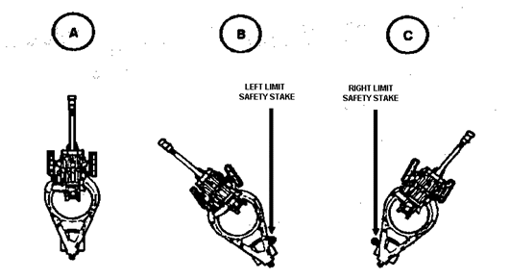

Figure 2-1. Establishment of M119 safety limits.

(3) Quadrant Elevation Safety Aids.

• Use the cam follower as an index mark.
• Set off the maximum QE on the fire control quadrant. Elevate the tube until the bubbles center in the elevation level vials.
• Mark the cam with a piece of tape in line with the cam follower.
• Mark the minimum QE in the same manner.

d. Emplace safety tape on the M198 howitzer as follows:

(1) Deflection Safety Aids.

• Place a piece of tape over the azimuth counter index mark (top carriage).
• Set off the left deflection limit on the pantel by using the deflection counter. Traverse the tube to pick up the proper sight picture on the aiming point.
• Place a piece of tape over the azimuth counter (bottom carriage) directly under the index mark.
• Mark the right deflection limit in the same manner.

(2) Quadrant Elevation Safety Aids.

• Place a piece of tape on the trunnion support as an index for quadrant elevation.
• Set off the maximum QE on the fire control quadrant. Elevate the tube until the bubble
centers in the elevation level vial.
• Place a piece of tape on the quadrant mount in line with the index mark.

• Mark the minimum QE in the same manner.

e. Emplace safety aids on the M109A2/A3 howitzer as follows:

(1) Deflection Safety Aids. These may be marked on the exterior and/or interior of the hull.

• Make an index mark on the top carriage with a piece of tape.

• Set off the left deflection limit on the pantel by using the reset counter. Traverse
to pick up a proper sight picture on the aiming point.

• Place a piece of tape on the bottom of the carriage directly under the index mark.

• Mark the right deflection limit in the same manner.

(2) Quadrant Elevation Safety Aids. These may be marked on the exterior or the interior of the weapon. Emplace the safety aids on the interior of the weapon, as shown in paragraph d(2) above. Mark the exterior of the weapon as follows:

• Mark an index on the tube with a piece of tape.
• Set off the maximum QE on the fire control quadrant. Elevate the tube until the bubble
centers in the elevation level vial.
• Place a mark on the top carriage in line with the index mark.
• Mark the minimum QE in the same manner.

f. Emplace safety aids on the M110A2 as follows:

(1) Deflection Safety Aids.

• Make an index mark on the turret.
• Set off the left deflection limit on the pantel by using the reset counter. Traverse
the tube to pick up a proper sight picture on the aiming point.
• Place a mark on the carriage in line with the index mark.
• Mark the right deflection limit the same way.

(2) Quadrant Elevation Safety Aids. These are emplaced the same as in paragraph d(2) above.

NOTE: When firing the M110A2, the spade tends to dig in causing the rear of the howitzer to rise. It may be necessary to recheck the elevation safety aids after several rounds are fired.

NOTE: Information on the M119 was not included in this
section due to a lack of doctrinal publications at the time
this document was written.

4. Weapons safety features many safety features are built into each weapon system to prevent accidental firing and injury to personnel. Each howitzer has its own particular safety features listed and described in the appropriate weapon TMs. However, these safety features are not entirely tamper proof. Only close supervision of crewmembers and frequent inspections of safety features can assure the supervisor that all components function properly. The two major types of breechblocks with built-in safety features are the sliding wedge (vertical or horizontal), and interrupted screw (with or without stepped thread). These two major types of breechblock are described here only to illustrate their safety features.

a. The sliding wedge breechblock (fig 2-2) is used on weapons that fire semifixed ammunition--currently the towed 105-mm howitzers M101A1 and M102. Two safety features are inherent--sliding breechblocks employ either the continuous pull (M101A1 howitzer) or the self-cocking (M102 howitzer) firing mechanism.

• First, if the breechblock is not fully closed, the firing pin cannot strike the primer.
• Second, if the tube is out of battery three-fourths of an inch or more, the firing pawl cannot activate the trigger shaft (firing plunger on the M102) to activate the firing mechanism.

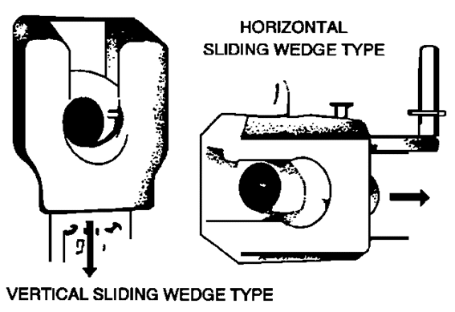

Figure 2-2. Sliding wedge breechblocks.

The breechblock is fully closed with the pawl in position behind the trigger shaft so that a firm pull on the lanyard fires the cannon. If the breechblock is not fully closed, the pawl does not make contact with the trigger shaft. Likewise, if the tube is not fully in battery, the trigger shaft cannot be moved far enough by the pawl to actuate the firing mechanism.

b. The interrupted screw breechblock (Figure 2-3) is used on weapons that fire separate-loading ammunition; that is, ammunition without a cartridge (propellant) case. There are two types in use--the interrupted screw breechblock without steps in the threads (Fig 2-3), used on howitzers with semiautomatic breech mechanisms (M109/M109A1/A3, 155-mm howitzer) and the stepped thread, interrupted screw breechblock (Fig 2-4) used on manually operated breech mechanisms (towed 155-mm howitzers M114A1/A2, towed 155-mm howitzer M198, and self-propelled 203-mm (8-inch) howitzer M110A1). The safety feature on this breechblock is as simple as it is critical. It is important to ensure full closure of the breech before firing because a partially open breechblock allows high-pressure gases to escape to the rear and into the crew compartment. This feature consists of witness marks painted on the breech ring and breechblock when fully closed. These rings indicate whether the breechblock is fully closed or not. When the breech operating handle is in the latched position and the witness marks are aligned (Fig 2-5), the breechblock is fully closed and safe to fire.

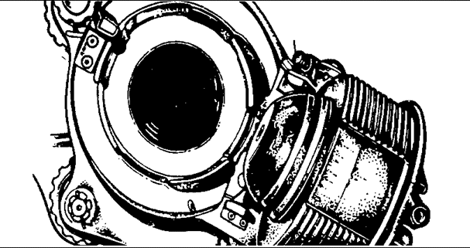

Figure 2-3. Interrupted screw breechlock.

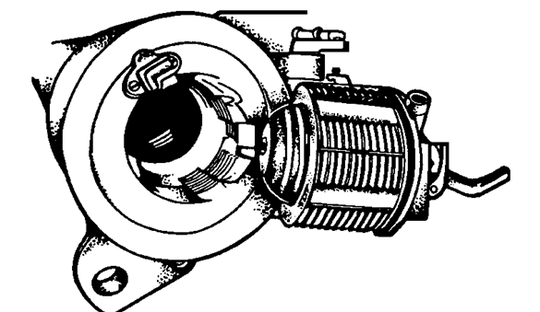

Figure 2-4. Interrupted screw, stepped threaded.

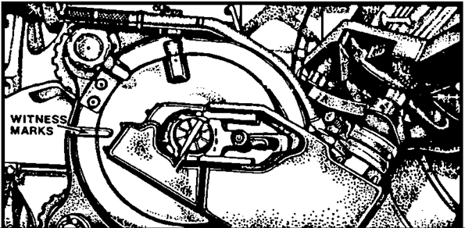

Figure 2-5. Witness marks indicating fully closed breech.

5. Maintaining weapon safety

Safety during firing must be emphasized at all times and made a positive action by every member of the firing battery. This means that any soldier observing an unsafe condition has the duty to prevent an accident by immediately announcing CHECK FIRING. The battery executive officer/safety officer and the howitzer section chief maintain safety during firing by taking action to preclude unsafe conditions as follows:

a. Verify the serviceability of ammunition.

b. Ensure only those charges, projectiles, and fuzes prescribed on the safety card are being fired.

c. Ensure rounds are not fired below the minimum quadrant elevation or above the maximum quadrant elevation.

d. Ensure time-fuzed rounds are not fired with fuze settings that are less than the minimum time prescribed on the safety diagram.

e. Require unused powder increments be displayed for each round to be fired.

f. On all commands are unsafe to fire, command "UNSAFE TO FIRE" and give the reasons. Examples are:

"UNSAFE TO FIRE, 3 MILS OUTSIDE RIGHT SAFETY LIMIT AND
20 MILS ABOVE MAXIMUM QUADRANT ELEVATION."

"UNSAFE TO FIRE, 5 MILS BELOW MINIMUM QUADRANT
ELEVATION."

g. Apply registration corrections to the safety limits immediately after registration.

h. (Chief of section.) Personally verify correct firing data are set on fire control instruments and that all bubbles are level.

i. (XO.) Upon occupation of position, indicate to the FDO when it is safe to fire.

j. (XO.) Suspend firing immediately when any unsafe conditions are observed or reported to him. Firing is not resumed until these conditions have been corrected. Examples of unsafe conditions are:

(1) Safety features of the weapon not operable.

(2) Powder bags exposed to fire.

(3) Personnel smoking near pieces.

(4) Improper handling of ammunition.

(5) Time fuzes previously set and not reset to safe.

(6) Personnel or aircraft directly in front of the weapons.

(7) Primer inserted into the firing assembly before breech is closed (separate-loading ammunition).

(8) Failure to inspect powder chamber and bore after each round is fired.

(9) Failure to swab powder chamber after each round of separate loading ammunition is fired.

k. (XO/SO.) Ensure howitzer crew members follow the prescribed procedures in case of a misfire (explained in lesson 3).

l. Report accidents and ammunition malfunctions as required by AR 385-63 and local regulations (explained in lesson 3).

6. Safety precautions for ammunition

The following precautions regarding the positioning and handling of artillery ammunition are not meant to be all-inclusive. Extensive and specific ammunition handling instructions are in the technical manuals pertaining to a particular weapon. The general safety precautions listed here are to be considered absolute minimums for all firing conditions/environments.

a. All ammunition on the ground at the firing position must be placed so it is protected against explosion in case of an accident at the piece. Fire and explosive or flammable materials must be kept away from ammunition. Ammunition should be protected from direct rays of the sun by use of a tarpaulin or other suitable covering.

b. Personnel must not attempt to disassemble fuzes.

c. If for any reason a round is not fired after the time fuze has been set, the fuze must be reset to SAFE before it is restowed. M514-series VT fuzes must be reset to the initial setting as shipped.

d. All rounds not fired but prepared for firing must be checked by the COS to ensure all powder increments are present, in proper order and condition, and of the proper lot number.

e. The piece is kept unloaded except when firing is imminent.

f. Personnel on the ground will pass in the rear of the carriage when they cross the direction of fire.

g. Personnel must stay a safe distance from the breech to prevent injury during recoil.

h. During firing, personnel should protect their eardrums against injury by using earplugs or other suitable material.

7. ACCIDENTS

The best policy regarding firing accidents is prevention. If firing battery supervisors assume accidents are caused and therefore preventable, they have taken that first step toward prevention. Every member of the unit must be alert for conditions that lead to accidents and either report such conditions to supervisors or take positive steps to remove the potential. Mistakes are often made by ill-trained troops.
Training, exact adherence to correct procedures, and emphatic enforcement of safety standards remove the potential for mistakes. Accidents occur when members deliberately disregard correct procedures in favor of short cuts. Close supervision and constructive, on-the-spot corrections prevent accidents.

a. Effectiveness. Inaccuracies in FA fire cause wasted rounds and a decrease in the effectiveness of fire support. Fire support is especially degraded when a firing accident results in loss of a weapon and its crew. A large percentage of inaccuracies and accidents can be attributed to careless and/or improper procedures in the firing battery. The following problem areas are a starting point for evaluating the level of training and safety awareness of a unit. These problem areas are only guides. They must be used together with aggressive supervision and an ongoing training program in which accident prevention is emphasized.

b. Common mistakes. Although these mistakes may seem obvious, they occur too often. Some common mistakes are:

(1) Firing a 100-mil error.

(2) Firing the wrong charge.

(3) Laying on the wrong aiming posts (especially at night).

(4) Transposing numbers.

(5) Failing to level pitch and cross-level bubbles.

c. Malpractice. Malpractice includes obvious violations of standard doctrine or procedures set forth in FMs, TMs, and other publications. The more common incidents to look for include:

(1) Having no system of double checks or leader checks on the actions taken.

(2) Exceeding the maximum and/or sustained rate of fire.

(3) Improper ramming, which may result in the projectile falling back on the powder when the tube is elevated (separate-loading ammunition). If the projectile falls back on the powder, expanding gases pass around the projectile (blow by). This decreases muzzle velocity. The projectile may be pushed forward toward the forcing cone. If so, the projectile will flutter and cause additional and unnecessary wear on the lands at the forcing cone.

(4) Improper testing of the gunner's quadrant.

(5) Improper or inconsistent placement of the propellant in the chamber.

(6) Incomplete and/or improper fire control alignment tests. These tests must be conducted in accordance with the technical manual to ensure the fire control equipment is synchronized with the cannon tube.

(7) Cannon tubes improperly secured in travel lock. This causes damage to the traverse and elevation mechanisms.

(8) Leaving projectiles and/or powder increments exposed to direct sunlight for prolonged periods of time. The result is erratic firing.

(9) Dropping projectiles or pallets of projectiles from the back of ammunition trucks or carriers. Damage to the fuze well or rotating band may result.

(10) Failing to clean projectiles before loading. The result is increased resistance in the bore and a dragging effect on the projectile during flight.

(11) Boresighting by the test target method in the field without compensating for the cant of the weapon trunnions.

(12) Attempting to boresight a weapon that is losing hydraulic pressure. The tube does not remain at a fixed elevation but depresses gradually, which causes errors in boresighting.

(13) Lifting a time-fuzed round with a hand around the fuze, easily changes the fuze setting.

(14) Failing to use a fuze wrench when tightening fuzes. This increases the chance of an in-bore explosion if gases escape around the projectile, or it may bring about a low-order burst upon reaching the target area.

(15) Failing to cross-level the collimator. The cross-level bubble must be centered before the collimator can be used as an aiming point.

(16) Firing a round through an oily tube. Tubes must be dry before firing.

(17) Removing the grommet protecting the rotating band before the round is placed in the bustle rack or on the loading tray.

(18) Improper procedures when transferring from primary to alternate aiming points during a fire mission.

(19) Attaching and/or picking up the lanyard before the
proper command is given.

(20) Standing in the path of recoil while priming or
performing misfire procedures.

(21) Failure to segregate propellant by lot number.

(22) Failure to perform prefire checks in each position.

(23) Failure to cycle through the GDU on each command, verifying the number of rounds, charge, fuze, and projectile. Chiefs of section often look at only the deflection and quadrant.

(24) Moving an SP howitzer when there is no radio communication between the chief of section and the driver of the howitzer.

(25) Improper shifting of trails on the howitzer. (Refer to the -10 TM for that weapon system).

(26) Failure to perform equipment PMCS on a routine basis, especially punching the tube of the howitzer.

d. Aiming circle errors. Generally, the person setting up the aiming circle is in a hurry--the battery is pulling in and he wants to get the guns laid as quickly as possible. This situation leads to careless procedures. Some of the more common errors include:

(1) Failing to tighten the instrument-fixing screw securely. The head of the aiming circle then turns/on the tripod, which causes an error in readings.

(2) Not clearing the area of magnetic attractions, especially weapons, steel helmets, and eyeglasses, when the magnetic needle is used.

(3) Failing to use a plumb bob and properly level the aiming circle, which can result in incorrect lay data.

(4) Failing to first roughly orient the 0-3200 line when measuring an azimuth or an orienting angle. This leads to 3,200-mil errors.

(5) Reading the red numbers rather than the black numbers on the azimuth scale.

(6) Not bringing the reticle hairlines from left to right.

(7) Failing to set up the tripod so that one leg points in the approximate direction of sighting. This puts one tripod leg in the instrument operator's way as he moves around and increases the likelihood he will knock the aiming circle off level (or worse).

(8) Inadvertently moving the lower motion when movement of the upper motion is desired. When this occurs, the 0-3200 line will be reoriented along a different azimuth.

(9) Making a 100-mil error in reading or setting. This is easy to do if you are not careful to read the numbers on the azimuth scale in a clockwise direction. When setting readings on the upper motion, it is best to set off 00 on the azimuth micrometer knob and then set the first two digits of the reading on the azimuth scale.

NOTE: See FM 6-50 Appendix D pages D5-D6, paragraph D-9 for additional errors.

e. When accidents occur. When firing accidents occur, the battery commander, XO, FDO, and other senior personnel present take immediate and firm action to maintain control and prevent additional injuries due to panic. An effective SOP helps when firing accidents occur. The SOP should prescribe immediate action for all personnel in the event of a firing accident. The SOP may include such guidelines as:

(1) Notify range control.

(2) Render first aid to injured personnel; then call for medical assistance.

(3) Do not change any settings on, or modify the position of the cannon in any way until an investigation has been completed.

(4) If the ammunition or equipment presents further danger, move all personnel out of the area.

(5) Record the lot number of the ammunition involved in the accident or malfunction, and report it to the battalion ammunition officer.

(6) If there is good reason to suspect a particular lot of ammunition, suspend its use pending completion of an investigation.

(7) Notify explosive ordnance disposal (EOD) personnel immediately so that a representative can be sent to the scene of the accident.

(8) When the suspension of a particular lot of ammunition has been substantiated by the responsible technical service officer, the suspension remains in effect until withdrawn by proper authority.

f. Reports. The OIC of firing and the safety officer must submit a complete report of all firing accidents. Depending on local regulations, such reports are routed through both command and safety channels to the next higher headquarters. Accident reports must be as complete as circumstances allow, but should include the following as a minimum:

(1) Ammunition lot numbers for all components; that is, fuze, projectile, propelling charge, and primer.

(2) Type of weapon, model, caliber, and carriage.

(3) Weapon serial numbers to include tube and breech numbers.

(4) Date, time, and location of the firing accident.

Additional data, as required by policy or regulations established by local commanders, should always be submitted in the interest of presenting facts to the fullest extent possible.

8. SUMMARY. Because of the potentially devastating effect of accidents in firing, safety must be the overriding concern of all members of a firing battery. Emphasis on safety and correct ammunition handling procedures should be second only to the field artillery's primary mission--to support the maneuver force.

Safety begins before the weapon is fired. Prefire checks are performed, ammunition and components are inspected/ safety data and range regulations are verified and enforced, and available safety aids are used. Weapon safety features are designed to preclude accidental firings--they must not be disabled or circumvented.

Lesson 2

PRACTICE EXERCISE

The following items will test your grasp of the material covered in this lesson. There is only one correct answer for each item. When you complete the exercise, check your answer with the answer key that follows. If you answer any item incorrectly, study again that part of the lesson which contains the portion involved.

1. Army regulation (AR 385-63) fixes responsibility for safety on the firing battery _______________.

A. section chiefs
B. section members
C. commanders
D. chain of command

2. A good safety device for towed howitzers deflection limits is (are) ________________.

A. index tapes
B. safety stakes
C. gunners quadrant
D. chalk line

3. The sliding wedge breechblock is found on cannons that fire ______________________________.

A. semifixed ammunition
B. semiloading ammunition
C. separated ammunition
D. separate-loading ammunition

4. Which type breechblock prevents a cannon from firing unless the breech is fully closed?

A. interrupted screw
B. interrupted screw, stepped threaded
C. sliding wedge
D. manual percussion

5. The safety feature on the 155-mm howitzer M109/M109A1/A3 consists of ___________________.

A. a grip safety
B. two positive safety blocks
C. proper alignment of pawl and trigger shaft
D. witness marks on the breechblock and breech ring

6. If any member of the battery observes a dangerous situation, he can stop a fire mission already in progress by announcing loud and clear the command _________________.

A. STOP FIRING
B. CANCEL FIRING
C. CEASE FIRE
D. CHECK FIRING

7. The battery executive officer must preclude unsafe conditions and prevent firing accidents by taking all except which of the following actions.

A. Require that unused powder increments be displayed for each round to be fired.
B. Personally verify that all bubbles on fire control instruments have been leveled.
C. Apply registration corrections to the safety limits immediately after registration.
D. Upon occupation of the position, indicate to the FDO when it is safe to fire.

8. Lack of training, or simple human error can cause mistakes, but malpractice is the result of a deliberate disregard for __________________.

A. life
B. leadership
C. rules and procedures
D. equipment

9. The failure to thoroughly clean a cannon tube of all lubrication before firing is considered a __________ error.

A. equipment
B. human
C. leadership
D. system

LESSON 2

PRACTICE EXERCISE

ANSWER KEY AND FEEDBACK

Item Correct Answer and Feedback

1. D. chain of command

2. B. safety stakes

Safety stakes . . . may be used as guides that indicate deflection limits.

3. A. semifixed ammunition

4. C. sliding wedge

5. D. witness marks on the breechblock and breech ring

The safety feature . . . consists of witness marks painted on the breech ring and breechblock when fully closed.

6. D. CHECK FIRING

7. B. Personally verify that all bubbles on fire control instruments have been leveled.

8. C. rules and procedures

9. B. human

Lesson 3

MISFIRE PROCEDURES

In this lesson you will learn how to perform the misfire procedures for semifixed ammunition weapons, separate-loading ammunition weapons, and the M198 howitzer.

Enabling Learning Objective

ACTION: Identify the misfire procedures for semifixed ammunition weapons, separate-loading ammunition weapons, and the M198 howitzer.

CONDITION: Given the information contained in this subcourse.

STANDARD: Correctly answer all of the questions on the practice exercise at the end of the lesson.
Answers must be in accordance with the content of the lesson.

REFERENCE: The material contained in this lesson was derived from FM 6-40, FM 6-50, ST 6-50-19, and other materials approved by US Army Field Artillery School.

1. GENERAL INFORMATION

a. General Definitions. The following is a list of general definitions:

(1) Check Firing. The command "CHECK FIRING" halts a fire mission. It is normally given by the executive officer but, in an emergency, may be given by anyone present.

(2) Cold tube. A cold tube has not exceeded the prescribed rates of fire and does not cause water from a wet swab to boil, fry, or steam off when placed just forward of the gas check seat on weapons using separate loading ammunition.

(3) Hot tube. A hot tube (Table 3-1) may or may not have exceeded the prescribed rates of fire. A hot tube causes water from a wet swab to boil, fry, or steam off when placed just forward of the gas check seat.

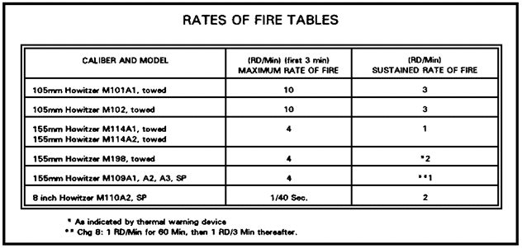

Table 3-1. Rates of fire.

(4) Cook off. A cook off is the ignition of the propelling charge initiated by the heat of the weapon. (This may occur when your howitzer has a hot tube.)

(5) Hangfire. A hangfire is a delay in the functioning of the primer, igniter, or propelling charge. This delay, though unpredictable, ranges from a fraction of a second to 10 minutes. The greatest danger in a hangfire situation is when either the firing lock or the entire breech is opened, allowing air to reach a smoldering charge. If the breech is open, air may fully ignite a hangfire and cause the full force of
the propelling charge to be discharged to the rear. If only the firing lock is opened and the primer is ejected, ignition of the propelling charge occurs and the weapon recoils normally. However, some hot gases emit from the primer vent and anyone in its path or in the path of recoil may be injured.

(6) Sticker. A sticker is a projectile lodged in the tube after normal functioning of the ignition train. Stickers may occur when firing at charges 1 with the M109A2/A3/A4/A5. When stickers occur, gases under high pressure are retained in the chamber.

(7) Misfire. A misfire occurs when the weapon does not fire after an attempt to fire has been made. This failure may be a result of the primer, igniter, propelling charge, or firing mechanism failing to function. A misfire in itself is not dangerous. However, it cannot be immediately distinguished from a hangfire or a sticker. Misfires must be treated as hangfires or stickers until otherwise determined.

b. General warnings. The following is a list of general warnings:

(1) In the event of failure to fire, keep the weapon trained on the target.

(2) Have personnel stand clear of the muzzle and path of recoil of the weapon. Ensure personnel do not get in the path of recoil when removing a primer that has not fired.

(3) Fire or unload chambered rounds from a hot weapon within 5 minutes.

(4) If the cannon tube is very hot from continuous firing, do not try to remove a chambered round.

(5) Do not fire high explosive (HE) projectiles left in a hot weapon more than 5 minutes.

(6) If an HE round chambered in a hot weapon can neither be fired nor removed within 5 minutes, ensure all personnel stand clear of the weapon (if the tactical situation does not permit evacuation) until such time as the weapon and chambered round are cool. Have EOD remove the round.

(7) Do not reuse rounds unloaded from weapons by ramming. Extraction may have caused some nonstandard conditions in the ammunition. Also, the fuze may have been damaged during extraction.

c. Special hot tube precautions. Specific hot tube precautions applicable to either semifixed or separate-loading ammunition are as follows:

(1) Do not load a round into the chamber of any weapon until immediately before firing.

(2) Fire or unload any round within 5 minutes after it has been loaded into a hot tube.

(3) If the round cannot be removed or fired within 5 minutes--

• Remove the primer and propelling charge or cartridge.

• Have the crew evacuate the weapon to a remote area away from the firing position.

• Let the weapon cool for 2 hours.

• Call EOD, to extract the round or evacuate the weapon.

d. Misfires and immediate action. Conditions described in this lesson are rarely encountered when authorized and properly maintained ammunition is fired in properly maintained and operated weapons. However, misfires do occur. When they do, specific actions are required within specified time limits.
Personnel injuries and equipment damage are avoided when all members of the firing battery understand:

(1) What is involved when the weapon fails to fire.

(2) What actions are required--and the necessary sequence in which they must be accomplished--when a failure to fire does occur.

2. SEMIFIXED AMMUNITION

NOTE: Information on the M119 is not included due to the lack of available doctrinal publications at the time this document was written.

a. Immediate action, semifixed ammunition, cold tube. Immediate action in a weapon using semifixed ammunition (105-mm howitzers M101A1 and M102) with a cold tube, is explained below and illustrated in Figure 3-2.

WARNING

UNAUTHORIZED ASSEMBLY AND USE OF CARTRIDGES IS EXTREMELY DANGEROUS. ENSURE PROJECTILES ARE MARKED 105H (NOT G OR R).

When the weapon fails to fire--

(1) Keep the weapon laid on safe firing data and trained on the target.

- Clear unnecessary personnel from the vicinity of the howitzer.

(3) Actuate the firing mechanism two additional times in an attempt to fire. If the weapon still fails to fire, wait 2 minutes from the last attempt to fire, then open the breech and remove the cartridge case. If the primer is dented, replace the cartridge case and fire the weapon. If the primer is not dented, repair the firing mechanism, reload the cartridge case and fire the weapon.

b. Immediate action, semifixed ammunition, hot tube. If a weapon using semifixed ammunition (Fig 3-1) fails to fire and the tube is hot, follow the same procedure outlined in paragraph a, and Figure 3-2. However, when the weapon cannot be fired or unloaded within 5 minutes from the time it was loaded, take the following action:

(1) Remove the cartridge case.

(2) Evacuate all personnel to a safe distance.

(3) Keep the weapon laid on safe data.

(4) Call EOD, extract the round.

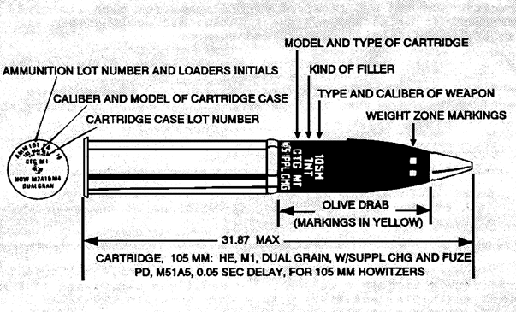

Figure 3-1. Typical markings, semi-fixed ammunition, 105mm Howitzers.

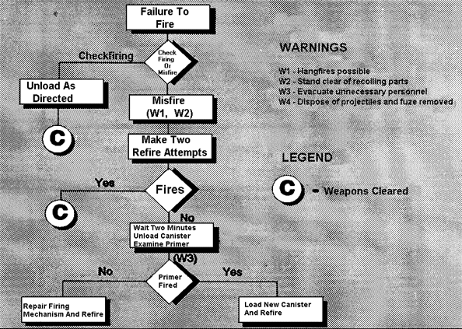

Figure 3-2. Immediate action flow chart on misfire procedures for semifixed ammunition in a cold tube.

3. SEPARATE-LOADING AMMUNITION

a. Causes of misfires. A misfire may result from the failure of the primer, igniter, propelling charge, or the firing mechanism.

(1) Primer. If the primer is dented but did not fire, the primer is at fault. This could be the result of a bad lot of primers. Any one of the components of the primer could be at fault. Replace the primer if it is found to be defective.



Figure 3-3. Unserviceable Primers.

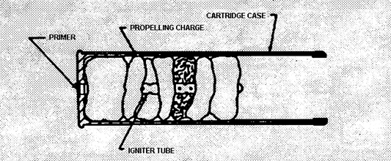

Figure 3-4. 105-mm cartridge case showing primer and igniter tube. Used with M101A1, M102.

NOTE: All weapons do not use the same type of primer. Refer to your TM for the appropriate primer for your weapon.

WARNING

ANY PRIMERS SHOWING SIGNS OF CORROSION OR DAMAGE SHOULD NOT BE USED.

(2) The igniter for separate-loading ammunition is in a cloth bag sewn to the end of the base charge on the propellant (Fig 3-5). Do not use propellant if the igniter is torn or wet. The powder grains may stick together causing a misfire.

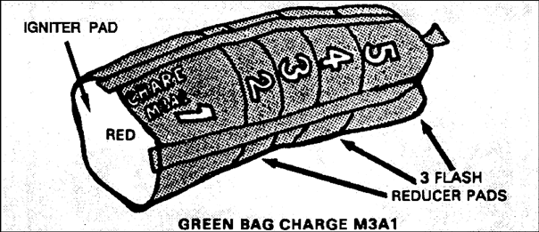

Figure 3-5. M3A1 propelling charge, 155-mm, green bag.

(3) Propelling charge. The propelling charge should have a sweet ether-like smell when taken out of its canister. If it has a sour, acid-like smell, the propellant has been wet. Wet powder does not burn properly and can cause a misfire. Propellant that is loaded incorrectly into the tube (that is, the igniter [red end] to the front instead of the rear) can cause a misfire.

(4) Firing mechanism. Most howitzers using separate-loading ammunition use the M35 firing mechanism. The M109A5 uses the M49 firing mechanism and the M114A1/A2 155-mm towed use the M1 firing mechanism.

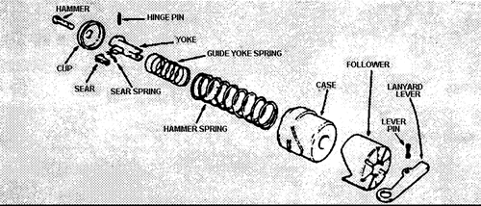

Figure 3-6. Firing mechanism, M35, M109, M198, and M110A2.

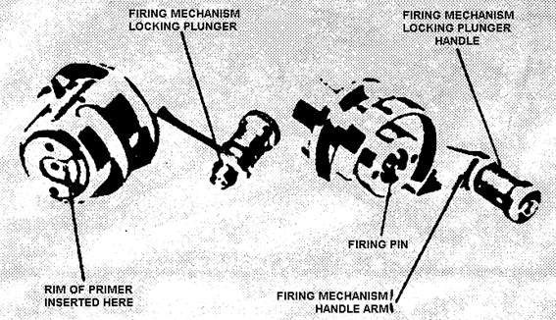

Figure 3-7. M1 firing mechanism for M114A1/A2.

Howitzers using semifixed ammunition use the M13 firing mechanism or the percussion firing mechanism.

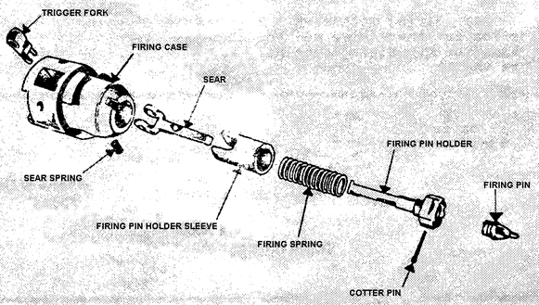

Figure 3-8. M13 firing mechanism for M101A1 howitzer.



Figure 3-9. Percussion firing mechanism for M102 howitzer.

Any one of the items associated with the firing mechanism may cause a misfire. This may occur if the springs are worn or damaged or if the firing pin is broken or blunted on the end. If the firing mechanism is found to be defective, replace or repair it.

b. Immediate action, separate-loading ammunition, cold tube. Field artillery cannons that use ammunition where the projectile, the propelling charge, and finally the primer are loaded into the weapon separately and in sequence, include:

(1) Self-propelled 155-mm howitzer M109A2/A3/A4/A5.

(2) Towed 155-mm howitzer M198.

(3) Self-propelled 203-mm (8-inch) howitzer M110A2.

(4) Towed 155-mm howitzer M114A2.

c. While the general misfire/checkfire procedures for separate-loading weapons apply to all the above cannons, there are a number of specific requirements applicable to only some of these weapons:

(1) Self-propelled 155-mm howitzer M109A2/A3/A4/A5: Do not use Charge 1 with these howitzers except under combat emergency conditions. When Charge 1 must be used, an occasional sticker may result. Infrequent stickers may also occur when firing charges 2 and 3. When stickers occur, gases under high pressure are trapped in the chamber. Removal of the primer is dangerous as it expelled is rearward with great force. The expelled primer and the escaping gases may cause injury to personnel in the path.

(2) A towed 155-mm howitzer M198 may also have a sticker at charges 1-3.

(3) If the weapon (separate loading--cold tube) fails to fire on the first try, immediately try to fire two more times. If the weapon still fails to fire, proceed as follows:

• Wait 2 minutes.

• Have personnel stand clear of the muzzle and path of recoil.

WARNING

DO NOT USE CHARGE 1 EXCEPT IN COMBAT EMERGENCIES.

• Remove and inspect the primer, exposing only the hand and arm.

• If the primer is dented but has not fired, insert a new primer and resume firing.

• If the primer is not dented, repair the firing mechanism/replace the firing pin, insert the primer, and resume firing.

CAUTION

A LANYARD OF AT LEAST 50 FEET SHOULD BE USED IF THE ROUND REMAINS IN THE TUBE LONGER THAN 15 MINUTES.

• If the primer has fired, wait 10 minutes from the first attempt to fire (8 minutes from removal of primer).

• Remove and replace the powder charge and insert a new primer.

• Resume firing.

d. Immediate action, separate-loading ammunition, hot tube. When a misfire occurs in a weapon using separate-loading ammunition with a hot tube, immediately attempt to fire two more times.

WARNING

WHEN AUTHORIZED RATES OF FIRE FOR CANNONS ARE EXCEEDED, PROPELLING CHARGE COOK OFFS MAY OCCUR WITHIN 1 MINUTE AFTER CHAMBERING.

WARNING

STAND CLEAR OF RECOILING PARTS. EXPOSE ONLY THE HAND AND ARM WHEN REMOVING THE PRIMER.

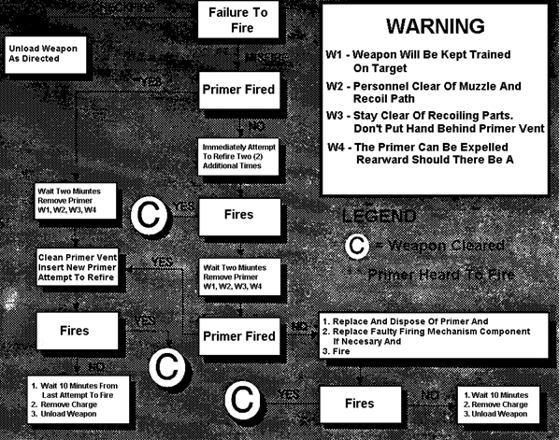

Figure 3-10. Misfire procedures, separate loading, cold tube.

NOTE: If the commander, decides to fire the projectile seated in a hot tube, it must be fired within 5 minutes of the time the projectile was chambered.

(1) Wait 2 minutes after the first firing attempt.

(2) Remove and inspect the primer, and observe sticker precautions when firing the M109A2/A3/A4/A5 with Charge 1-3.

(3) If the primer is dented but has not fired, immediately insert a new primer and resume firing.

(4) If the primer is not dented, immediately repair/replace the faulty firing mechanism or component and resume firing.

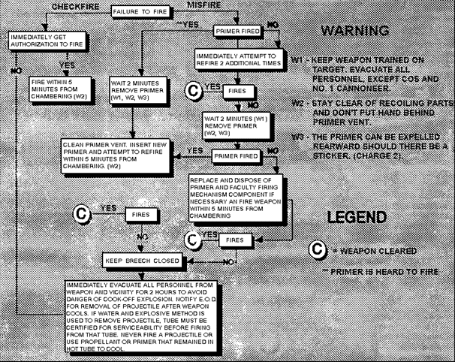

Figure 3-11. Misfire procedures, separate loading, hot tube.

(5) If the primer has fired, evacuate all personnel from the weapon and notify EOD for removal of the projectile or evacuation of the howitzer. Wait 2 hours, then go to step (7).

NOTE: Under combat emergency conditions, quickly insert a new primer and resume firing.

WARNING

DO NOT OPEN THE BREECH IF THE WEAPON FAILS TO FIRE.

(6) If the weapon still fails to fire, and after all personnel have been evacuated from the howitzer, wait 2 hours.

(7) After 2 hours, remove the primer and propelling charge.

(8) Place waste rags in the chamber.

(9) Close the breech.

(10) Lock the cannon in the traveling position.

(11) Carefully move the weapon to a remote location.
WARNING

DO NOT ATTEMPT TO REMOVE THE PROJECTILE. THE HEAD OF THE TUBE ACTING ON THE RELATIVELY COOL PROJECTILE MAY CAUSE THE SHELL TO CRACK. SOME OF THE HIGH EXPLOSIVE FILLER MAY MELT AND ACCUMULATE INSIDE THE TUBE AND CHAMBER. THIS CREATES AN EXTREMELY DANGEROUS SITUATION.

(12) Request EOD or direct support maintenance personnel to remove the projectile or evacuate the cannon with the seated projectile.

e. Sticker procedure (M109A2/A3/A4/A5), cold tube. If the weapon fails to fire, a sticker condition cannot be readily determined. Therefore, proceed as follows:

(1) Immediately attempt to fire two more times.

(2) If the weapon does not fire, wait 2 minutes.

(3) Evacuate extra personnel a safe distance from the howitzer.

(4) Position the tube so the primer can be expelled through the rear opening in the cab.

(5) Stand to the right of the breech. Manually grasp the knob on the firing lock assembly 1 (Fig 3-12) and pull outward until it is free to be opened.
WARNING

DO NOT STAND BEHIND THE BREECH WHEN REMOVING THE PRIMER. DO NOT GRASP THE FIRING LOCK ASSEMBLY WITH YOUR HAND DIRECTLY BEHIND THE FIRING MECHANISM.

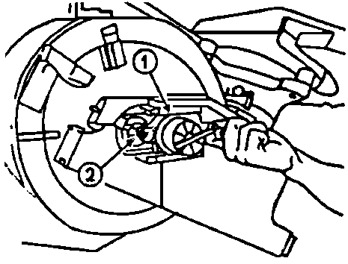

Figure 3-12. Opening the firing lock.

(6) Keeping the knob out, firmly slide the firing lock assembly toward the right (open position) until the primer (Fig 3-12) is ejected and the gases are vented.

(7) If a sticker occurs, get proper authority and refire at Charge 4 or above.

NOTE: No significant range loss is expected when firing stickers.

(8) If a sticker is not involved, replace the faulty component and refire or clear the weapon.

f. Sticker Procedure (M109A2/A3/A4/A5), hot tube. If a misfire occurs while firing the M109A2/A3/A4/A5 howitzer using Charge 1-3 and the tube is hot, the condition may be a mechanical malfunction, component misfire, hangfire, or sticker. Since the exact condition cannot be determined beforehand, cautiously follow these procedures:

(1) If the weapon fails to fire on the first attempt, immediately attempt to fire two more times.

(2) If the weapon does not fire, wait 2 minutes after the last firing attempt.

(3) Evacuate extra personnel to a safe distance from the howitzer, open the rear door of the cab, and position the tube so the primer will be expelled through the opening in the cab.

WARNING

IF A HANGFIRE CONDITION EXISTS, PRIMER REMOVAL MAY EXPOSE THE CANNONEER TO THE DANGER OF A RECOILING WEAPON.

NOTE: If the commander decides to fire the projectile, it must be fired within 5 minutes of the time the projectile was chambered.

(4) Stand clear of the path of recoil and well to the right of the breech. Manually grasp the knob of the firing lock assembly and pull outward until it is free to be opened. Keeping the knob out, firmly slide the firing lock assembly toward the open position until the primer is expelled and the gases are vented or the primer is ejected normally.

(5) Inspect the primer if it is ejected normally.

WARNING

IF THE PRIMER HAS FIRED, A HANGFIRE OR STICKER CONDITION CONTINUES TO EXIST.

(6) Immediately insert a new primer and refire the weapon.

WARNING

DO NOT OPE THE BREECH. DO NOT ATTEMPT TO INSERT A NEW PROPELLING CHARGE.

(7) If the weapon still fails to fire, evacuate all personnel, but keep the weapon laid on safe firing data.

(8) Wait 2 hours, then proceed as follows:

• Remove the primer and propelling charge.

• Place waste (rags or other material, Fig 3-13) in the powder chamber.

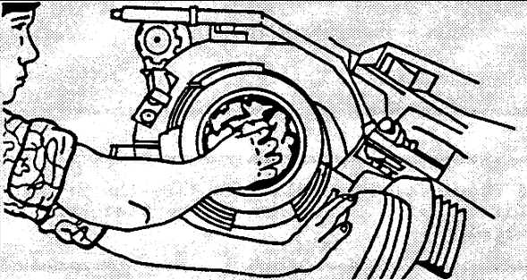

Figure 3-13. Place waste in the powder chamber.

• Close the breech.

• Lock the cannon in traveling position.

• Carefully move the weapon to a remote location.

CAUTION

DO NOT ATTEMPT TO REMOVE THE PROJECTILE.

(9) Request EOD or direct support maintenance to remove the projectile or evacuate the cannon with the seated projectile.

4. SUMMARY. In the rare evert that a misfire occurs, the XO or plt ldr and the howitzer crew members must be familiar with the exact procedures for a particular set of conditions. Cold tube misfires are less critical but can be just as dangerous as hot tube misfires if handled improperly; and a hangfire or sticker can present very hazardous conditions. If an accident occurs, injured personnel must receive first aid and proper reports must be submitted; data on the cannon must not be disturbed. Mistakes are usually the result of improper training, malpractice, or willful violation of established procedures. Most mistakes and malpractices can be avoided by aggressive supervision. On-the-spot corrections and other forms of control will foster good habits and discourage sloppy procedures. Emphasis on proper procedures and safety in training will prevent accidents in firing and result in more accurate and effective fire. The key to minimizing human error and careless gunnery procedures is proper training.

Lesson 3

PRACTICE EXERCISE

The following items will test your grasp of the material covered in this lesson. There is only one correct answer for each item. When you complete the exercise, check your answer with the answer key that follows. If you answer any item incorrectly, study again that part of the lesson which contains the portion involved.

1. The best way to avoid a sticker, a round that has lodged in the tube after firing, is to--

A. use charge 1 for short ranges only.
B. fire charge 1 only from the M109A2/A3/A4/A5.
C. keep the tube well lubricated so the round won't stick.
D. never fire charge 1 with the M109A2/A3/A4/A5.

2. Because a sticker condition cannot be readily determined, your immediate action when a weapon fails to fire (M109A2/A3/A4/A5, cold tube) is to make two more attempts to fire, wait 2 minutes if it still fails to fire, and then--

A. refire at charge 4 or above.
B. open the firing lock to vent the gases.
C. evacuate extra personnel a safe distance from the howitzer.
D. call EOD to remove the lodged projectile or evacuate the weapon.

3. If a misfire occurs in a hot tube and all subsequent attempts to fire the weapon also fail, the breechblock must remain closed for at least--

A. 2 hours.
B. 1 hour.
C. 10 minutes.
D. 5 minutes.

4. In any case where a projectile was loaded into a hot tube, it must be fired within--

A. 2 hours.
B. 1 hour.
C. 10 minutes.
D. 5 minutes.

LESSON 3

PRACTICE EXERCISE

ANSWER KEY AND FEEDBACK

Item Correct Answer and Feedback

1. D. never fire charge 1 with the M109A2/A3/A4/A5.

2. C. evacuate extra personnel a safe distance from the howitzer.

3. A. 2 hours.

4. D. 5 minutes.

NOTE: If the commander . . . decides to fire the projectile . . ., it must be fired within 5
minutes . . .

APPENDIX A

INTRODUCTION

All cannoneers of a howitzer crew are assigned specific duties to perform in order to respond rapidly to fire missions. In order to train personnel as members of a cannon field artillery section, the section chief assigns specific duties to each member of his section. For training, they are assigned titles, or numbers. You must understand this method, so you can properly supervise your unit's performance in all circumstances. When all cannoneers in a section perform their assigned duties, the section can rapidly emplace the howitzer, and have rounds on the way to the target upon request. Training this task to proficiency allows the section to operate with a reduced section because each man knows the duties of other members of the section. The name of the game in a howitzer section is: TEAM WORK!!



